WHITE FOX RARE BOOKS AND ANTIQUES LLC

LONDON INTERNATIONAL ANTIQUARIAN BOOK FAIR
2013

NATIONAL HALL ~ OLYMPIA

STAND 359

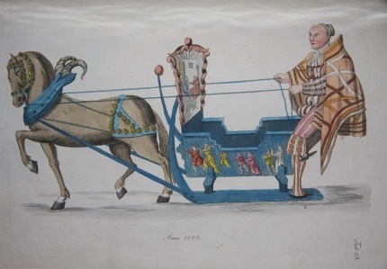

Color Plate and Other Illustrated Books
Illustrated Albums and Sketchbooks
Leporellos
Fine Bindings
Faux Books
Ephemera

Peter F. Blackman 001 (802) 291-4113
974 CEMETERY ROAD, WEST WINDSOR, VERMONT 05089 U.S.A.
info@whitefoxrarebooks.com www.whitefoxrarebooks.com

All items on the list below are subject to prior sale. Prices are rendered in both dollars and pounds. The pound figure is based on the prevailing conversion rate in May. If the pound should have appreciated vis-à-vis the dollar in the interim, we will happily adjust the pound- denominated price at the point of sale to the benefit of the purchaser.

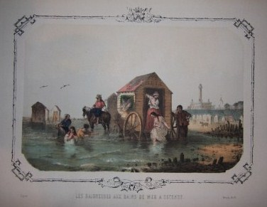
Album D'Ostende. Bruges and Ostende: J. Buffa. N.d., circa 1860. A fabulous collection of hand-colored plates of the popular Belgian beach resort, with a mix of character studies (mostly of the local, non-fashionable citizenry), humorous genre scenes and views of the beach, the architecture, the beachgoers, the sea. Illustrators include Cham, Victor Eeckhout, H. Borremans, van Cuyck, Gerlier, F. Stroobant, J. Van de Putte, Baldisseroni, de Nestele (?) [spellings of these names somewhat elastic]. 52 plates in all, all but one of which is hand-colored, the final plate is a folding tinted panorama of the beach looking in from the sea . Some of the beach scenes are evocative of Boudin. The mix of humor and more sober portraits lends a balance from which we can better approximate the culture and atmosphere at this early destination resort. And through the pictures we can sense the uneasy embrace of the vacationing bathers with the sea. The colored plates are all 13.5 by 10 inches, or 34 by 25 cm, including their margins. The plates are mostly clean, but there is some finger soiling and the like in the margins, and a few plates have chips and small chunks of card missing, never affecting the images. Rebacked with attractive green morocco. The contemporary cloth boards are soiled, with a few minor edge dings. No title, and no evidence there ever was one. Very Good. Half Morocco . (#001956) $4,500 £2,980

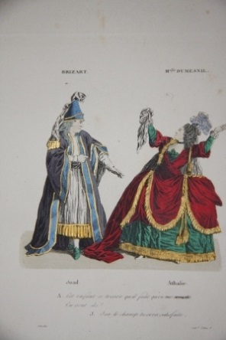
Album Dramatique. Souvenirs de L'Ancien Theatre Francais. Depuis Bellecour, Lekain, Brizard, Preville, Armand, Auger, Feulie, Paulin, Belmont, Grandval, MMes. Dumesnil, Clairon, Les Deux Sainval, Preville, Hus, Doligny, Bellecour, Fannier, jusqu'a Mole, Larive, Monvel, Vanhove, Fleury, Desessart, Dazincour, Dubazon; MMes Raucourt, Vestris, Contat, Ollivier. Gravures Coloriees. Representant en pied, d'apres les miniatures originales, faites d'apres nature, de Foech, de Basle et de Whirsker, ces different acteurs dans les roles ou ils ont excelle. Paris: Corbeil. De Crete., 1820. First edition. 46 intricately hand-colored plates of scenes from French theater. 8vo. 25 by 17 cm. Scarce collection, with no listing found in the major bibliographic sources (Colas, Lipperheide, Hiler), and only six institutional copies located on OCLC. The plates are not merely costume plates, but rather capture dramatic or comedic moments in the plays of the era, from the classics such as "Electra" and "Andromaque" to less lofty popular fare, and it provides a visual record of the most important actors of the day. A surprising number of the pieces depicted, such as the plays of Beaumarchais, remain well-known to our times. Light rubbing to the red morocco on raised spine bands and edges. Half title and title are heavily foxed. Occasional light foxing to the plates, which are otherwise bright and fresh. Very Good. Half Morocco. (#002569) $2,500 £1,660

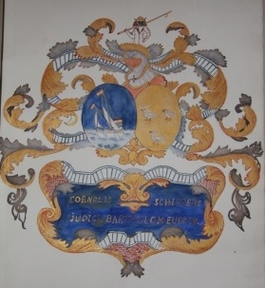
[Album] E.E.B. Collection de Porcelaines de Chine Armoiries. 35 spectacular original watercolors of armorial china ornament. All the specimens come from a single collection, which presumably was that of the artist, of whom only the initials E.E.B. we know. Three of the paintings have explanatory captions; otherwise, the armorial decoration speaks for itself. Each painting is protected with tissue and often a blank sheet of similar card stock. Folio, 12 by 10 inches, 30 by 26 cm. Handsomely bound. Both delightful and enchanting. Near Fine. Full Morocco, with slipcase. (#002579) $2,500 £1,660

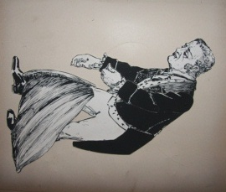
Album of Humorous Cut-Out Figures, Detailed with Penwork, And Some Movable. England. Highly unusual and original album of cut-out figures, loosely in the style of an Edward Lear. N.d., early 20th century. With 21 leaves. There are images of early cars and scooters, and a reference to Teddy's braces, which is probably referencing Theodore Roosevelt. Most of the figures, though, could easily be late Victorian as much as Edwardian. The juxtapositions on some of the leaves can be manic, and that is part of the fun, in addition to the figures with movable parts. The effect is that of collage. There is the occasional political reference, but there would seem to be no agenda other than the nihilism of humor and caricature. Rebacked with green morocco. A few leaves have apparently disappeared, based on the evidence of offsetting, but since there is no narrative, the loss, such as it might be, would otherwise not be noticed. A few of the cut-outs have become loose, and a few others have minor losses (a limb, and the like). Regardless, a wonderful piece of home made entertainment. Good. Quarter Morocco. (#002282) $2,000 £1,325

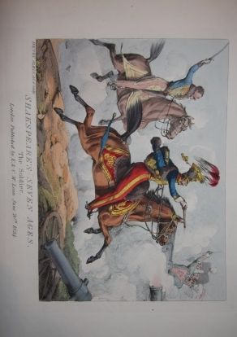
Alken, Henry, illustrator; Shakespeare, William. Shakspeare's [sic] Seven Ages of Man. London: E. & C. McLean, 1824. First Edition. A classic series, with some of Alken's most memorable work. Oblong 11 by 16.5 ins., 28 by 43 cm. The hand-colored plates depict the seven ages of man as summarized famously by Shakespeare: "The Infant", "The School-Boy", "The Soldier", "The Lover", "The Justice", "The Sixth Age", "The Last Scene of All". Abbey Life 256. Tooley 47. Note Shakespeare is spelled without the "e" after the "k" on the front cover of the wraps and all the plates, something not noted by Tooley. Alken brings a quintessential light touch to each of these, including the final scene which one might have expected to be somber and grim. Scarce, with the original wraps and title page. All protected in a cloth chemise. Bookplate on inside board of this folio is abraded. The wraps have a few creases and wear but remain essentially sound. A few light finger smudges in the margins afterward. Mostly clean and bright. Near Fine. Original Wraps, housed in a cloth folio. (#002587) $2,950 £1,955

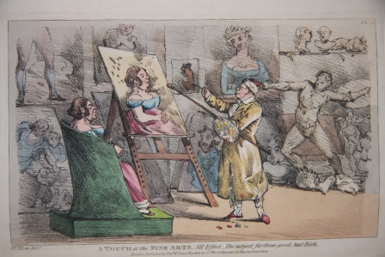
Alken, Henry. A Touch at the Fine Arts Illustrated by Twelve Plates, With Descriptions, by Henry Alken. London: Thomas McLean, Repository of Wit and Humour, 1824. First edition. A humorous take on the argot of art criticism. 8vo. With 12 hand-colored aquatint plates, including frontis, which is described as Plate V. The apercus of Alken, as he applies phrases others must have used to describe, praise and pan his own efforts, are singular in not being susceptible to easy description. However, he succeeds ably in capturing the pretentious tone of the critic in his elaboration of phrases such as "an imposing effect", "a sudden effect", "a warm effect". For most, the magic and fun is in the illustrations, in which he attempts to give literal application of these terms. The binding is a later (1911) full red straight-grained morocco by Zaehnsdorf. With gilt-fillet borders and gilt lettering and details on the spine. Also one page publisher's advertisement at rear, but without half-title. The binding has light rubbing along the front joint and there are rubbed spots along the edges and by the corners, but the binding remains very handsome indeed. Excepting a few occasional, light fox marks, the plates and text are clean. There is an armorial bookplate on marbled FEP. Tooley 58. Near Fine. Full Morocco. Plus (#002354) $1,800 £1,195

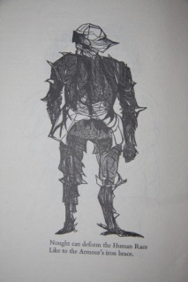
Baskin, Leonard, illustrator. William Blake. Auguries of Innocence by William Blake. Northampton, MA: The Print Club of Philadelphia, The Gehenna Press, 1959. Limited First Edition. No. 200 of 250 limitation, signed and numbered in pencil by Leonard Baskin. This was Baskin's first venture into publishing, and his jagged and stark illustrations amplify the fire and brimstone of Blake's both naive and worldweary verse that lilts at the same time it pierces and challenges. Printed on an Italian hand-made paper, this is indeed a very handsome brochure, and this copy is pristine internally, with the faint remnants of tape top and bottom on both the front and rear of the wraps the only minor blight to the special production. Near Fine. Wraps. (#002184) $1,200 £795

Bastian, R. Wo Schwatze mia. Spruche aus meiner Lothringischen Heimat So schwatze mir dahemm. Merlenbach: Lehrerbildungsanstalt Metz-Montenich, 1943. Dialect humor with colorful vignette illustrations from Nazi Era Germany. Sixteen loose leaves on card, with original drawings and humorous text, written in dialect and with German Fraktur Gothic type. The loose leaves, all of card, are housed in a modern green cloth folio folder with title, etc. imprinted on front in gilt. Near Fine. Folio Folder. (#001936) $1,200 £795

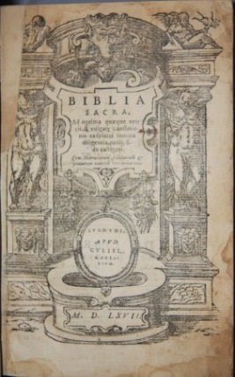
Biblia Sacra, Ad optima quaeque veteris, & vulgate translationis exeplaria summa diligentia, pariq; fide castigata. Cum Hebraicorum, Caldaorum & Graecorum nominu interpretatione. London: Apud Guliel, 1567. First Edition Thus. 8vo. [16], 1176 pp. Followed by long unpaginated glossary and index. With many woodcut illustrations throughout, varying sizes, with sometimes nearly full page to small vignettes, and often two or more illustrations on a page. Modern vellum that with Gothic lettering on spine, is compatible with the 16th century text. Text block is tight. Some soiling near front in lower corner and scattered soiling beyond, but for age toning, the text is quite clean. The woodcuts are of varying sharpness, but that is a function of their printing. Very Good. Full Vellum. (#002001) $3,200 £2,120

Bembo, Pietro. Gli Asolani. Venice, 1546. Book. Second edition of this famous "Dialogue" treating the subject of love which was dedicated to Lucrezia Borgia. 104 leaves, and numbered accordingly, or 208 unpaginated pages, measuring 6 by 4 inches. Vellum with label on spine with letters "ASO and "BEMBO" discernible. Title with woodcut illustration of soldier in armor, his sandaled foot on globe, eagle at his side. Sides of illustration blackened by what looks like watercolor or ink. Otherwise only light soilage throughout, and binding is tight, making this a good or better copy. Good+. Hardcover. (#000762) $975 £645

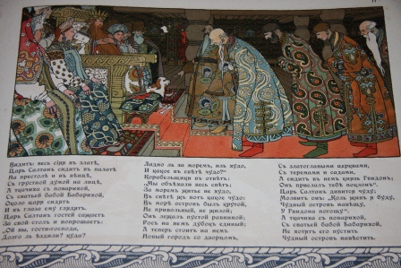
Bilibin, Ivan, illustrator. Story by Alexander Pushkin. Skazki Pushkina Skazka o Tsar Slatanje (Tsar Slatan). St. Petersburg: The Department for the Production of State Documents [Expeditsii Zagotovleny Gosudarstvennukh], 1905. First Edition. Hauntingly beautiful chromolithographic images by Ivan Biliban. Oblong, 4to, measuring 32 by 26 cm, and 20 pp., featuring ten chromolithographs in addition to front cover, title and the rear cover vignette. Five of the chromos within are full page. In addition, there is the chromo decorative borders, very much a part of the integral whole. This work is part of a series of indigenous fairy tales the Russian government commissioned Bilibin to illustrate. To do so Bilibin paid meticulous care to actual traditional costume, architecture and decor. The work cemented Bilibin's renown, which was also built on stage design. The front cover is soiled and the coloring is dulled. The imagery is bright elsewhere. The wraps also have a slight curl. Very Good Minus. Wraps. (#002545) $1,200 £795

Boccalini, Traiano. De Ragguagli di Parnaso. In questa decima Impressione da infiiti errori diligentemente espurgata (2 volumes). Amsterdam: Giovanni Buaeu, 1669. Book. 12mo - over 6¾ - 7¾" tall. [16], 471, [57]; 415, [41], 139, [23] pp., 3 parts in two volumes. Including etched additional title and 2 blanks. Popular political and literary satires in the form of news reports from Parnassus. Brunet 1019 singles this edition out as the prettiest. Also Graesse 456. Eighteenth century Italian vellum with morocco lettering pieces. Armorial bookplates of Wilmopt, Earl of Lisburne. Some scattered foxing. Binding is tight, vellum is attractive and healthy. Very good or better! Very Good. Hardcover. (#001031) $700 £465

Boland, John, engraver. The Path to Perdition or a Scene from the Back Room in the Days When Life Was Simple, With Apologies and a Toast to John Held Jr. Master Eng. and Forty Famous Cocktails, Being a Compendium of Reliable Recipes Carefully Compiled for Use in this Arid Era, Engraved with Humble Apologies to That Master Engraver John Held Jr. New York: Colonial Sales Corp.. First Edition. Scarce Prohibition piece of ephemera, with charming color woodcuts on two sides and pull that reveals recipes for forty drinks. N.d.,circa 1930. Soiling mostly on the bottom, below imagery, and some general wear. The pull still functions well, and the flat movable retains all its charm. Very Good. (#002594) $750 £497

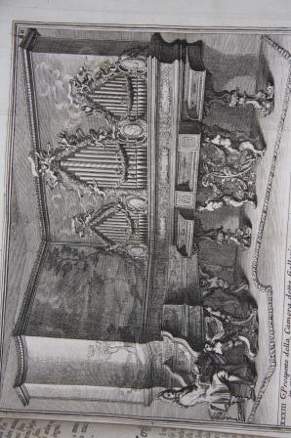
Bonanni, Filippo [also spelled Buonanni]. Gabinetto Armonico. Pieno d'Istromenti Sonori Indicati, e Spiegati. Roma: Giorgio Placho, 1722. Second edition. Small 4to. (24 by 19 cm, 9.75 by 7.25 inches. [16], 177, [1] pp, including half-title. With two engraved frontispieces and 151 engraved plates of musical instruments and their players. One plate is folding. Some of the instruments are fanciful. Instruments also include non-European instruments. The instruments were in the collection of the Collegium Romanum where Bonanni was a professor of mathematics. Contemporary sprinkled sheep with gilt decoration and raised bands on spine. Some rubbing to spine, more pronounced on bands. Abrasion by upper front joint. Some scuffs on boards. Interior is tight, and such soiling as there is on the leaves is light, occasional and inobtrusive. There was an inscripion at the bottom of title page that someone removed and in doing so left some abrasion and pinprick holes, again, not obtrusive. Fine. Full Sheep. (#001425) $11,500 £7,650

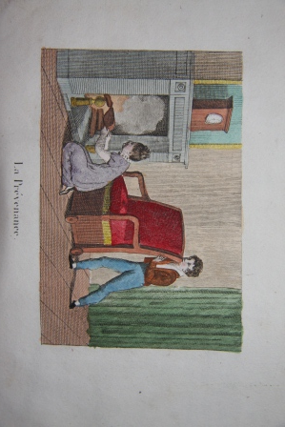
Les Bons Exemples ou Jolies gravures morales et amusantes avec un petit conte pour chaque sujet. Ce petit recueil Dedie aux Enfans des deux Sexes . . . Paris: Chez Lecerf et Chez Blanchard, 1830. Fourth Edition. A juvenile charmer scarce with hand-colored illustrations. N.d., circa 1830. Oblong, 12 by 18 cm, 7 by 4.75 inches. 22 pp. plus 10 hand-colored plates in addition to allegorical vignette on title. Each of the illustrations accompanies a short story, or anecdote or apercu, that highlights a virtue. In a sense, this is an emblem book intended for children. The virtues, all of which are both titles of the individual pieces and captions to the plates, are Courage, Sobriety, Charity, Diligence, Filial Devotion, Fraternal Love (featured twice), and Modesty. The hand-coloring is delicately and elegantly applied, making this work an outstanding specimen of the genre from the Restoration period (Biedermeier, or Regency period as well). With a neat owner's inscription from 1833. Original paper pastedown boards are heavily soiled and worn but nonetheless survive with their integral qualities intact. Light soiling to the leaves, never disconcerting. A few leaves were cut sloppily, with the resulting margins uneven and the lines of text at a diagonal. Very Good. Paper pastedown on boards. (#002565) $850 £565

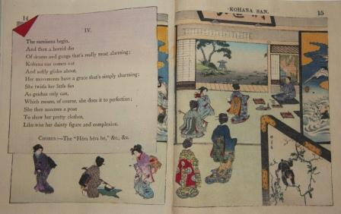
Bostwick, Lieutenant F. M. Artist unknown. Kohana San. Tokyo; Yokohama: T. Hasegawa; Kelly & Walsh, Ltd., 1892. 19 pp. With a song about a geisha written by a naval officer, Ensign, then Lieutenant, F. M. Bostwick, who was in Japan for a three-year tour of duty beginning in 1886. Enthralled by the society around him, Bostwick contributed two musical manuscripts to Hasegawa, the first being Lyuchasan. A bit of departure for Hasegawa, the two works nonetheless sold extremely well for many years after. Sharf 32-3. Minor edge creasing of a few leave corners and slight bunching of the fabric by the front cover joint. Small stamp on p. 1 from presumably first bookseller. The first internal leaf has light foxing and p. 3 has light soiling by the joint. Otherwise bright and clean. Very Good. Crepe Paper bound with ribbon. (#002097) $600 £398

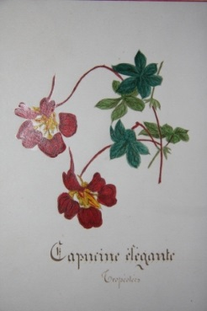
Botanical Album with Original Illustrations of Flowers. . 22 plates or original ink and watercolor depictions of flowers and a textual description, in French, alongside. Compiled probably by a student, this album is an exceptionally beautiful example of the genre. The handwritten descriptions are done with a calligraphic hand. Flowers include colchique, belle a nuit, fuchsia, capucine, etc. N.d., circa 1870s. No title, bound in quarter morocco over marbled boards. Oblong, 26 by 36 cm. Marbled pastedown of cover abraded around perimeter. FFEP torn by lower hinge. Plates are on a near card stock and very well preserved. Very Good. Quarter Morocco over Marbled Boards. (#002580) $2,000 £1,325

[Botanical] Album of 15 Pencil and Watercolor Drawings of Flowers, Butterflies and Birds. . N.d., but papers watermarked 1816 to 1825, so circa 1825. Also unsigned, but album cover bears initials of H.C. B. Stunning album of pencil and watercolors of flowers, butterflies, birds and nests. 15 drawings in all. All expertly done. Fine. Full Morocco. (#001634) $2,200 £1,457

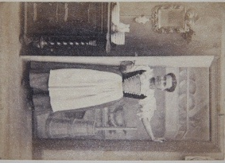
Braun, Adolphe. Costumes de Suisse. Lucerne and Dornach (Alsace), respectively: Fortune Aubert; Agence de la Maison Ad. Braun. Scarce collection of photographic costume plates, with no copies located on OCLC. N.d., circa 1869. With 36 mounted photographs of Swiss women in provincial dress and either engaged in prototypical activities are surrounded by the paraphernalia of such activities. In a neat cursive in the lower margin is written the city that the photo was taken, and so each woman shown is in a sense representative, in her dress and activity, of the named place. Adolphe Braun (1812 - 1877) was a French photographer known for floral studies, Parisian street scenes and Alpine landscapes. In 1855 he was awarded a medal at the Exposition Universelle held in Paris that year. Later he created a business that focused on photographic reproductions of important paintings and sculpture, and his company became a leader in that field. While the set of photos contained in this album have faded somewhat, one can not but be impressed with the sharpness of elements in the image. There is a painterliness to the compositions: the women and their dress might be the primary subject, but many of the images also feature floral decoration and Alpine backgrounds. (#002471) $2,250 £1,490

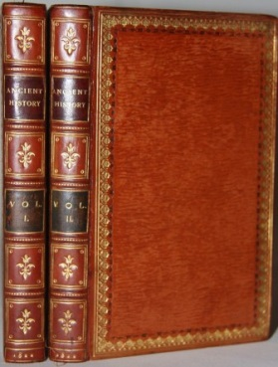
[Budden, Maria]. Ilustrated by Mr. Brooke. True Stories from Ancient History; Chronologically Arranged. From the Creation of the World to the Death of Charlemagne (Two Volumes). London: J. Harris and Son, 1822. First Edition Thus. Exceptional copy of this juvenile history, including 72 exquisitely hand-colored vignettes, two per leaf, or 36 plate leaves, including the two frontis leaves. (Most copies of this book lack color.) 12mo, measuring 6 by 4.5 inches, or 16.5 by 10 cm. viii, 195, iv, 192 pp. t.e.g. Pretty gilt incised figures within spine compartments, and floral band around perimeter of boards, with marbled endpapers. An occasional fox mark, but overall, clean and tight. Fine. Full Calf. (#001941) $1,400 £925

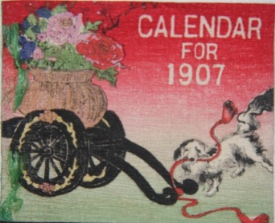
Calendar for 1907. Tokyo: Isekin & Co., 1906. First Edition. A scarce miniature Japanese crepe paper calendar, in the style of Hasegawa or Kobunsha but in this case, of Isekin & Co., with brilliant coloring, espeically in the reds. The curiosity piece measures a mere 8 by 6.5 cm (3 by 2.5 inches) oblong. With the covers, front and back, there are 26 pages. When opened, one side gives the calendar for a month and its facing leaf features an illustration that is tied in with the declared significance of the month. Thus the illustration for August relates to the Feast for the Moon, for June, the peony. The delightful item is almost pristine, with but one tiny corner crease and perhaps the vague outline of a former such crease. Fine. Ribbon Ties on Crepe Paper. (#002178) $500 £332

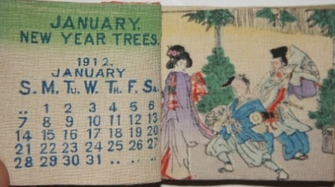
Calendar for 1912. Tokyo, 1911. First Edition. A scarce miniature Japanese crepe paper calendar. The curiosity piece measures a mere 5.75 by 6.5 cm (2.25 by 2.5 inches) oblong. With the covers, front and back, there are 26 pages. When opened, one side gives the calendar for a month and its facing page feature an illustration. In the style of a Hasegawa crepe paper calendar, but no publisher given and most certainly another publisher. Some waviness or rolling to the crepe paer and trivial edge creasing. Also trivial cover soiling. Near Fine. Ribbon Ties on Crepe Paper. (#002513) $500 £332

[Cards] Deck of Miniature Playing Cards, Uncut. . N.d., circa 1900. The cards are very much in the style, pictorially, of a Piatnik deck, with lush color and ornate, literal detail, except these are truly miniature cards, with each card measuring 2 by 1.4 cm, and they are uncut! Truly a rarity as well as a novelty. Fine. (#002521) $200 £133

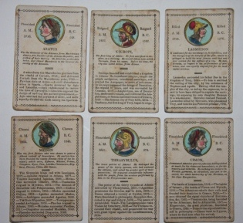
[Cards] Historical Cards Exhibiting the Grecian History. London: John Wallie. N.d., late 18th century. With 31 (of 32) cards, each with a colored medallion of a Greek ruler, general or warrior, or adversary of note -- the emphasis is squarely on the powerful and martial, not the cultural. The figures include Aridaeus, Pisistratus, Agesilaus, Epaminondas, Philip, Darius II, Bessus, Brennus, Agis, Philopeomenes, Cleomenes, Antigonus, Antiochus the Great, Scipio, Perseus, Lysander, Themistocles, Cassander, Agis, Demetrius, Pyrrhus, Sosthenes, Cimon, Alexander the Great, Thrasybulus, Aegialeus, Medon, Agamemnon, Laomedon, Cecrops and Aratus. The coloring adds charm to the otherwise brief, matter-of-fact brief biography. Not that these are men who would have played themselves in the movies, based on the images! Scarce, with the only known copy owned in the past by the British Museum (and possibly now in the British Library, although nothing shows up in its general catalogue). The cards have soiling, with one of the cards having minor loss (a letter or two of a word) along a crease. Surviving also is the original box, which has substantial losses along the edges and is heavily soiled, but the top with the title is still legible. Good. Box. (#002530) $750 £497

[Chinese Interest] Album of Chinese Faces. . Seventy-nine Chinese faces, all delicately drawn and/or painted directly onto the leaves. The collection is rich in the variety, represently a superb cross-section of adult Chinese faces. While all the men and women are serious in their expression, their faces are suffused with character. Many have clearly had an arduous life. The faces also evince an ethnic diversity within the Chinese population -- the eye sets, the shape of noses, and other features, are considerably more varied than the stereotype in the West. N.d., circa mid to late nineteenth century. Oblong, 23 by 12.5 cm, 9 by 5 inches. Wear, spotting to the wraps. Two pinprick holes in leaves, not affecting the images ever, and not disconcerting. Very Good. Wraps. (#002573) $3,000 £1,990

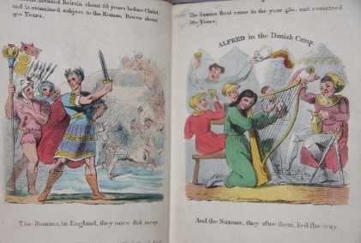
Mr. Collins. The Chapter of Kings. Illustrated by Thirty-eight Engravings Exhibiting the Most Important Events in English History. London: J. Harris, 1818. First Edition. 12mo, 5.25 by 4.25 inches, 14 by 11 cm. As noted in title, with 38 hand-colored plates depicting the kings of England. Each plate has a header caption relating a salient fact about the particular king, and the bottom caption carries a line of doggeril that rhymes with the facing page. The book was intended as an instructive text for children, as noted on the rear cover: "Parents and Teachers must have remarked the difficulty Children experience in recollecting the Succession of the English Monarchs, and likewise how much the memory is assited by rhyme." The blurb also notes the "correctness of the Costume and Design". Modern audiences will undoubtedly find the plates suffused with a gory charm, and this is also an early textbook featuring hand-coloring. Light wear to the binding as well as light soiling to the pages. Overall, quite clean and attractive. Very Good. Blindstamped Cloth. (#002532) $650 £430

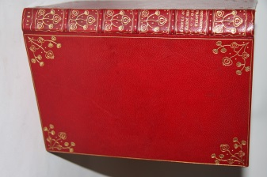
Combe, William. Illustrated by Thomas Rowlandson. Journal of Sentimental Travels in the Southern Provinces of France, Shortly Before the Revolution. London: Rudolph Ackermann, 1821. First Edition. 8vo. (23 by 14.5 cm.) [2], ii, 291, [1] pp., With 18 handcolored aquatint plates by Rowlandson. Text by Combe (uncredited) has a delightful levity without the doggeril that afflicts his once very popular light verse. The rich red morocco, by Wood, is tooled with Art Nouveau gilt floral decoration on the spine and the four exterior and two interior corners of the boards, the casing making this a copy of exceptional beauty. With bookplate of the Duke of Gloucester. Abbey Travel 89. Tooley 415. Bound without advertisements, as the norm. Other than the most minor of scattered soiling, the interior is clean as are the plates. Fine. Full Morocco. (#001937) $1,750 £1,160

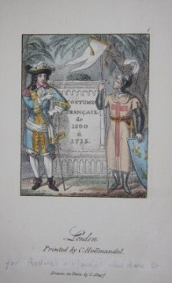
Costume Francais de 1200 a 1715. London: C. Hullmandel. 12mo, 5.5 by 4. 5 inches, or 14 by 11.5 cm. 100 hand-colored lithograph costume plates, all immaculate. Leaves are printed only on one side, and the plates resemble stylish costume cards. This book is usually found with only black and white plates. Other than minor toning along the edges, the thick paper looks virtually new. All is bound in a lush modern reddish-orange morocco, with gilt and incised decoration on both the boards and spine. The gilt figures incorporate the shape of the fleur-de-lys and come off both tastefully simple and elegant. The leather has a particularly substantial look, atypical of a book this size, and it is also in superb condition. The green marbled endpapers complete the package of this petit charmer. Fine. Full Morocco. (#001974) $1,500 £995

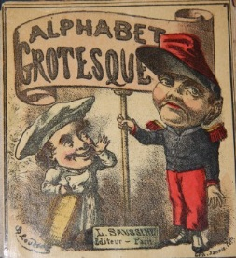
Coudert, B., artist. Jannin, lithographer. Alphabet Grotesque. Paris: L. Saussine. N.d., circa 1850s. Leporello with twelve leaves of colored plates featuring amusing caricatures of types representing most of the letters of the alphabet. Thus we have pictures of an "Acteur", "Bossu" (a hunchback), "Chiffons" (rag-picker), "Decrotteur" (shoe-black), "Enfant", "Gourmand", "Hareng" (fish-wife", "Invalide", and onward. Not all the letters are used in the illustrations. Really, the point is to present a panorama of the colorful characters and trades that might be considered street-life, or perhaps more simply, amuse. The depictions would fail miserably more recent standards of "political correctness", but their power to touch the funnybone has not the least diminished. Listed in Segoline Le Men's "Les Abecedaires francais illustres du XIXe siecle", 297.The leporello panels measure 12 by 11 cm each; when fully, the leporello is 12 by 122 cm. The surface is glossy, as called for (papier glace). It is housed in a more modern quarter leather and marbled boards binding. Fine. Quarter Leather. (#001993) $2,800 £1,855

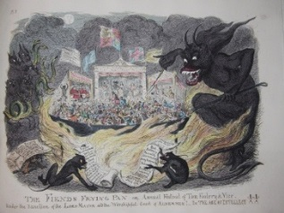
George Cruikshank. Scraps and Sketches. London: Published by the artist, sold by James Robins and Co., 1828-1832. First Edition. Oblong folio, measuring 11 by 15 inches, 39 by 28 cm. [2] pp. followed by 24 color plates. Most of the plates have multiple comical vignettes (four to nine of such), with four plates with a single larger image. A title relatively uncommon in commerce, and unusual in that Cruikshank himself undertook the publishing of it over four annual installments. Cohn 180. With the title to the first installment serving as the title overall, and the title of the other installments, as well as Robins catalogue advertisements, lacking. The black cloth binding is scuffed and lightly soiled. Chipping and rubbing along joints but binding stable. The plates are clean and bright. Very Good. Cloth, with Leather Spine Label. (#002501) $600 £400

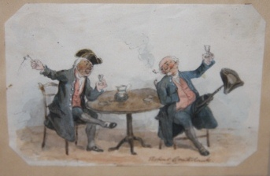
Cruikshank, Robert. Original Ink and Watercolor Illustration by Robert Cruikshank Depicting Two Older Men Drinking, Smoking and One with a Pegleg Holding Up His Three-Cornered Hat. . N.d., circa 1820. Robert Cruikshank (1789-1856) was the son of Isaac and brother of George and particularly known for his miniature portraits, a gift evident in this small painting. It is impossible to pinpoint a date on this particular painting. The dress is late eighteenth, early nineteenth century, suggesting a work done earlier in Cruikshank's career, although there is no reason to rule out a nostalgic look back at some later date. The scene is of two elderly men perhaps toasting to something, sitting at a table enjoying themselves. Part of the humor of the scene is from one having a pegleg and using it as a hatrack. The picture itself measures 11 by 8 cm, or 4.5 by 3 inches, and it is mounted on another sheet of paper or card, which is then mounted, matted and framed. The frame itself is 23 by 22 cm, or 9 by 8.5 inches. (#002317) $1,400 £930

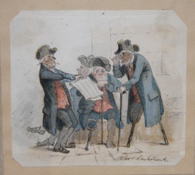
Cruikshank, Robert. Original Ink and Watercolor Illustration by Robert Cruikshank Depicting Two Peg-Legged Men Being Shown a Newspaper. . N.d., circa 1820. Robert Cruikshank (1789-1856) was the son of Isaac and brother of George and particularly known for his miniature portraits, a gift evident in this small painting. It is impossible to pinpoint a date on this particular painting. The dress is late eighteenth, early nineteenth century, suggesting a work done earlier in Cruikshank's career, although there is no reason to rule out a nostalgic look back at some later date.The scene is of four older men, one in the background, two who have lost part of their leg, and one with two peg-legs. One should think that they are old naval salts, now retired and spending their days together, bickering about the current alarming state of the world and their past exploits, and this is rendered with a light, humorous touch. The picture itself measures 10 by 8.5 cm, or 3.5 by 3.75 inches, and it is mounted on another sheet of paper or card, which is then mounted, matted and framed. The frame itself is 23 by 22 cm, or 9 by 8.5 inches. (#002316) $1,400 £930

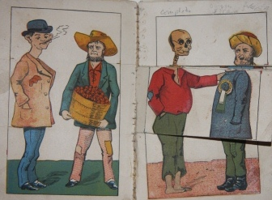
Cunningham & Reynolds Metamorphic Book. Cincinnati, OH: Jos. Wachtel, printer. A very colorful and delightful metamorphic book, with 18 flap panels (six pages if closed, which can be superimposed on the inside back and front covers, to create hundreds of different characters and dress, all very amusing. N.d., circa late nineteenth century (1880s in all probability). The book was issued by Cunningham & Reynolds of Chattanooga, Tennessee, which was in the business of selling boilers, engines, saws, corn mills -- heavy duty hardware and farm equipment, in other words -- and this was surely a promotional freebie. The book itself is bound with stitching, which appears original. The covers are soiled heavily, and there is some abrasion loss on the rear cover. There is a slight bend to the covers and leaves. The flaps within are not 100 percent tight, but they are complete, and it is easy to enjoy the changing of images as much as ever. A scarce piece of Americana and also a scarce metamorphic or toy books. (#002494) $350 £232

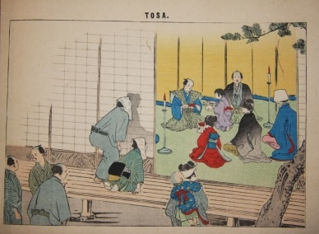
Curizuka, Mrs. R. [Mrs. Rio Crizuka]. Japanese Wedding Ceremonies Old and New. Tokyo: Sold by K. Ogawa and Kelly & Walsh, 1904. First Edition. Oblong, measuring 10 by 7 inches, 25 by 18 cm. 31 folded leaves, with color plates or illustrations on both sides of most of these leaves, plus a folded plate, and title leaf. 22 pages are of text which is divided between a key to the illustrations, describing what is happening in each one, and a more general exposition on Japanese weddings, which is materially different from Western weddings at the time not only in the ceremonial practices but also in a broader understanding of the arrangement itself, which was in Japan, essentially a contract between two families with much less religious and governmental overtones and involvement. The book came out virtually coincident with the premiere of Puccini's opera, Madama Butterfly, and just a few short years after the David Belasco play upon which it was based, and so interest in Japanese wedding practices was running strong then. Fans of the opera will still find interesting the discussion of the go-between or marriage broker. Overall this is a colorful, easily digestible exposition on an important topic of Japanese traditional culture, and the title is nonetheless a scarce one to come by. Soiling of the front and rear. There is a minor closed tear along the fold of the front, and a few the leaves are creased along the upper left edge. By the rear spine in the upper corner there is chipping, or minor loss, to some leaves, not at all affecting content. Minor edgewear besides. Good. (#002552) $475 £315

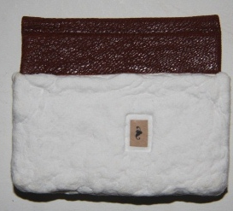
D'Ambrosio, Joseph J. Mr. and Mrs. Potato. Limited First Edition. One of 50 copies of this artist's book. 13 pp. No copyright claimed, with it expressly stated that the story was lifted from the Internet! The delightful short short story revolves around the upbringing of Mr. and Mrs. Potatos daughter, Yam, and the punchline turns on a pun! An inimitable miniature book, in pristine condition. Like New. Quarter Morocco, with Linen linters-formed Mashed Potato, With slipcase and sleeve. (#002244) $475 £315

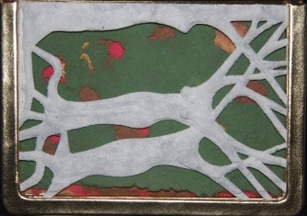
D'Ambrosio, Joseph J. The Small Garden of Gloria Stuart. Limited First Edition. No. 49 of 50 copies of this artist's book inspired by the movie star Gloria Stuart (1910 -2010). Ms. Stuart was a leading lady in the 1930s and early 1940s, best known then for her roles in "The Invisible Man", and many decades later, after a long retirement from the movies, for her role in "Titanic" in 1997. Ms. Stuart, though, was far from idle during her many years away from acting, and her multifarious productivity away from the camera are every bit as fascinating as her Hollywood career. Besides being a political activist sympathetic to liberal causes throughout her life, Ms. Stuart was active in the decorative arts as a designer and business owner, and she enjoyed considerable success as a primitivist painter as well. Most pertinent to this book, Ms. Stuart became both an ardent gardener and an artisan printer, producing artist's book in which she did virtually everything, including the writing, the designing and the printing. While this book was written and produced by Joseph J. D'Ambrosio, a celebrated California book artist, it is a celebration and homage to Ms. Stuart's achievements, and some of the elements in the book such as the overlay of foliage imagery are a nod to Ms. Stuart's own work. This D'Ambrosio creation impresses with many other clever effects such as its intricate paper cuts of the preliminary pages to conjure up a three dimensional illusion of forest and trees, with the foreground a caryatid of two tree trunks shaped like women's bodies. D'Ambrosio has bestowed on us an object of revelatory beauty, and while the aesthetic is unabashedly modernist, the spirit is traditional artistry and artisanship at its best. The book, which is modest in size, a little over 6 inches tall, is in mint condition, and it is protected with a cloth box that contains a felt repository or well in which the book resides. Like New. With Box. (#002221) $1,000 £663

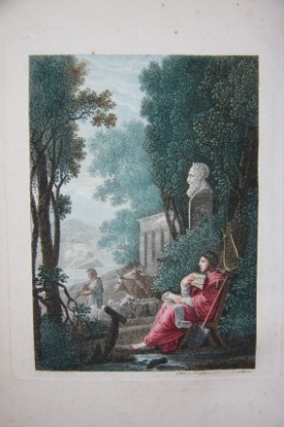
Delille, Jacques. L'Homme des Champs, ou Les Georgiques Francoises Nouvelle Edition Augmentee, Avec Figures. Paris: Chez Levrault, Schoell et Cie. (L'Imprimerie de P. Didot L'Aine), 1805. 8vo. 225 pp. With four plates and eight vignette illustrations, two each at the beginning of each of the four "chants", all hand-colored sensitively. These are by Catel and engraved by Buchorn, Guttenberg, Halderwang et Mayer. Cohen-de Ricci 279. An updated adaptation of Virgil's masterpiece. The contemporary hand-coloring sets this copy apart from others of this work. The soft coloring -- in the spirit of Fragonard or Boucher -- perfectly suits the bucolic subject matter. Red morocco boards are particularly thick, rendering a box-like solidity to the book as an object, which is further enhanced with gilt work along edges. Light foxing throughout but generally not affecting significantly the plate and illustration pages, thus suggesting that it is very much a function of the acidity of the paper used for the text proper. Very Good Minus. Full Morocco. (#002061) $1,200 £795

Della Casa, M. Giovanni. Il Galateo (Volgare e Latino) (Giuntovi il Trattato degli Uffizi comuni l'Orazione a Carlo V. L'Orazione alla Repubblica di Venezia, e le Rime. Venezia: Simone Occhi, 1750. Book. 16mo - over 5¾ - 6¾" tall. 358 pp. Della Casa's sixteenth century manual on court etiquette rendered in both Italian and Latin. (It was published originally in Italian, and later translated by Nicolo Fierberto.) Gamba 285. Also included in this volume is Della Casa's treatise on how a subordinate should treat his superior in government and his "Rime" or verse. This copy is tight and generally clean. The title page has two pin-sized holes forming a colon after the title, with no loss of lettering or content, and a few of the preliminary pages after have minor corner creases in the lower corner. The vellum has a few brown stain spots in the lower front, yet the vellum remains healthy and attractive. Some bowing to the boards, as typical of vellum. Very Good. Hardcover. (#001204) $325 £215

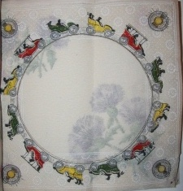
Dennison Mfg. Co. Dennison's Napkins for the Season of 1905. Boston, 1904 (?). Folio (14.5 by 9 inches), containing 35 decorative napkins made of crepe paper. Intended for tea parties and other festive occasions, the napkins, which fold over once to close the binder, measure 14 by 14 inches. They were sold in packages of 500 and carried names such as "Music", "Tea", "Floral", "British Flag", "Lily", "Playing Cards", "Japanese", "Aster" -- this should give an idea of the nature and range of designs. Surely they are among the earliest examples of paper tableware. There is one more specimen than appears to be called for on the inside cover. Scarce, with no copies located on OCLC. The front board is cracked along the hinge but now secured and sturdy. Minor closed tears along the folds of the now brittle napkins. Very Good Minus. Card stock wrappers. (#002517) $850 £565

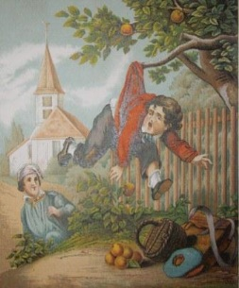
Derosiers, D. F. L'Ecolier Parisien. Paris: Bernardin-Bechet Libraire-Editeur. N.d., circa 1890. Unpaginated, with ten pages of text and six amusing chromolithographic plates, including that on the front cover of the wraps. Charming story about city boy's mishaps when moved to country. Scarce, with no copies found on Worldcat nor in such works as Gumuchian. Measures 27 by 13 cm, 10.5 by 9 inches. Light soiling to the wraps. Otherwise clean, crisp, fresh. Near Fine. Wraps. (#002106) $300 £199

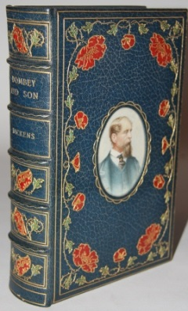
Dickens, Charles. Illustrated by "Phiz" (Hablot Knight Browne). Dealings with the Firm of Dombey and Son. London: Bradbury & Evans, 1848. First Edition. First edition in book form. Dickens' classic housed in a splendid Cosway-style binding that is in pristine condition. "Dombey and Son", though a beloved part of the Dickens' canon, is less often encountered in such a binding than other works by the master. This Cosway binding was created by Bayntun (Riviere) of Bath, England. The centerpiece medallion on the front board is a portrait of Dickens painted onto ivory by Miss C. B. Currie. Surrounding the cameo are floral vines, very much in the arts and crafts style, with deep green leaves, red flossoms and gilt lines. Similar motives ornament the compartments of the spine, and the rear board has matching border decoration to the front. All edges of the text block are gilt, and there is fine gilt detail surrounding the endpapers. The text block is tight, and the pages are mostly clean. There is one tiny closed tear in the margin of pp. 13/4. While there is some light foxing on the plates, overall the leaves, text or illustrated, are cleaner than almost always encountered. 8vo, xvi, [errata], [blank], 624 pp. 39 plates. The book comes with a protective cloth clamshell box. Fine. Full Morocco. (#002186) $6,500 £4,310

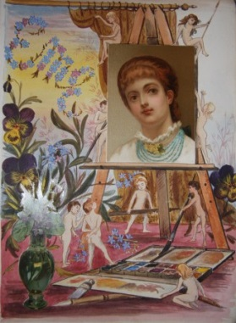
E.M.E. Album Incorporating Chromolithographic Cards and Die-Cuts into Fabulous Watercolored and Inked Illustrations. . N.d., circa 1880s. Forty leaves with fabulous mixed media illustrations in which printed chromolithographic material is creatively incorporated into original watercolor and ink illustrations. The far greater part overall is the original artwork, all done by a highly skilled hand possessed by E.M.E., whose wild imagination is evident both in how the pasted material was seamlessly worked in and in the artwork that was entirely her (or his) own. Each leaf is 14 by 11 inches, or 36 by 26 cm, and of a stiff and sturdy card stock, with art is entirely on the recto side, with the backs kept blank, and they are bound in the album with tabs. The identity of E.M.E. is unknown, but he/she was surely English, and there can be no question all of the work was done by one hand. Not only is every leaf initialed, but there is a flow to the album, and that too adds to its inimitable charm. The first leaf depicts an artist's easel, with pixies working busily away to set things up, and E.M.E.'s initials are traced in floral decorated swirls in the sky beyond. We are treated, as we proceed through the album, to all kinds of creatures, animal, impish, exotic. We travel to the Italian Lakes, Japan, the English and Scottish countryside, the coast, Holland, the eighteenth century, etc. Images are meant to delight at times with their humor, at other times their element of surprise, or their sheer beauty. All kinds of characters and animals appear in the illustrations, but the pixies and nymphs prance flit through the entire work, although not in every illustration by any means. Finally, the last leaf is captioned "Bon Soir, Au Revoir", meaning the album has come to its end. Surely E.M.E. drew inspiration from printed imagery and even emulated what he might have seen, but that does not negate from his contribution in the least. And to us it offers a special time capsule to the interests and tastes of the era as telling as a tome on cultural history. The blindstamped cloth binding has wear but remains solid. The leaves are generally clean and attractive. Very Good Plus. Cloth. (#001980) $18,500 £12,250

[Ephemera][Pop ups] Collection of Nine Herbert Tareyton Miniature Pop-Up Cards of the Sights of England. The sights included are Warwick Castle, Christ Church College Oxford, Kenilworth Castle, Parliament, St. Paul's Cathedral, Covent Garden Theatre, Lincoln Cathedral, Windsor Castle and the Horse Guards. All but the last three also include the envelope in which they came. All the pop-ups, if not unopened and unused, work fine. Fine. (#002575) $200 £133

[Faux Book] Boite a Cartes Suze Aperitif. . N.d., circa 1900. Suze, a well-known spirits company in France, was established in 1889 and remains in business to this day. This book-shaped wooden card box has a piece of wood that slides open on the fore-edge. The handsome box measures 12 by 7 cm, 5 by 2.75 inches. The blue surface paint is rubbed and worn through, giving it an attractive aged patina. On the top a longish sliver of wood had become cracked without falling off. This has been repaired. Good. (#002556) $150 £99

[Faux Book][Inkwell] Traveling inkwell shaped like a miniature book: Baedeker's Wien. . Late 19th century. Made to look like travel guide to Vienna. With gilt depiction of Stefankirche on front board. Measures 2.5 by 2.5 by 1 inches, or 6 by 6 by 3 cm, and weighs 3 ounces. Loss of morocco along edges from wear. Metal of spine seems raised over boards, although this may be how it was originally fabricated. Effect is still a slight loss of centering. Still opens and closes as should and overall appearance is attractive and a convincing impostor. Extremely rare novelty. Good. (#001332) $450 £298

[Faux Book] [Inkwell] Traveling inkwell shaped like a miniature book: The Pocket Classics. Royal Edition. Three Volumes. . Late 19th century. Measures 2 by 2 by 1.25 inches, or 5 by 5 by 3 cm, and weighs 2.3 ounces. Loss of morocco along edges from wear. Some looseness of remaining leather from metal. Metal somewhat bent in a few spots. Still opens and closes as should and overall appearance is attractive and a convincing impostor. Extremely rare novelty. Good. (#001329) $450 £298

[Faux Book] Matchbox Shaped like a Miniature Book, with Full Morocco Binding. . N.d., circa 1900. Elaborate gilt detailing on spine and boards of full morocco binding for this lovely matchbox measuring 6 by 4 cm. Rubbing along edges and spine. Worn but attractive. Very Good Minus. Full Morocco. (#002597) $165 £110

[Faux Book] Music Box Shaped like a Book. . Music box plays two tunes. Fully functioning, with stop and lever adjustment for choice of tunes. Very convincing simulcrum of a book. Opens with small storage space, probably meant for small toiletries. Full blindstamped calf has considerable wear. Sides or foreedges of metal with lines to suggest pages. Also colored headbands. 5.5 x 4.5 x 2.5 inches, 140 x 110 x60 mm. Key to wind up is newish, or not original. As a music box, this is in very good condition. It can be a little fickle or fussy, but generally responsive and tunes ring out with clear and charming timbre. As a book form, with the wear described, this might be considered good minus. A nifty novelty. Good Plus. Full Calf. (#001341) $795 £527

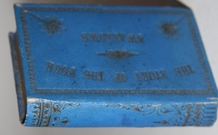
[Faux Book] The Story of the Four Swallows. . N.d., circa late nineteenth century. Shaped like a miniature book (or near minature), this box opens up to reveal four slots for tiny liquor bottles. Two of the original bottles survive, both corked, one labeled "Irish", the other, "Port". The binding is a blue morocco, marked "Germany", and with typical Greek Revival ornament so common in bookbinding during the mid-19th century. The inner lining, or endpapers, have a fleur-de-lys diaper pattern. The box measures 8.5 by 5 cm. Minor wear to the leather. Very Good. Full Morocco. (#002585) $175 £116

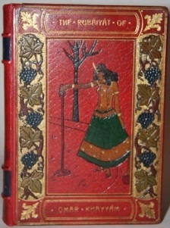
Fitzgerald, Edward, translator. Gilbert James, illustrator. Rubaiyat of Omar Khayyam With Twelve Illustrations after Drawings by Gilbert James Coloured by Hand. London and New York, respectively: George Routledge & Sons, Limited; E.P. Dutton and Co., 1908. James' distinguished renderings, hand-colored, are housed in a stunning Bayntun full morocco onlay binding depicting a slave girl pouring out wine from a carafe, with side panels of grape vines surrounded by pointillist gilt. The leaves are of a heavy Japon paper, making this a particular attractive edition. The spine has been rebacked sympathetically. The board corners on the inside are crackled slightly. Two preliminary leaves, one being the back of the frontis plate, have two inch tears from the joints out; these do not penetrate through the thick, double sheeted paper, and thus are best left alone. The frontis plate on the pictorial side is entirely unaffected. Otherwise, clean and tight. Very Good. Full Decorative Morocco. (#002457) $850 £565

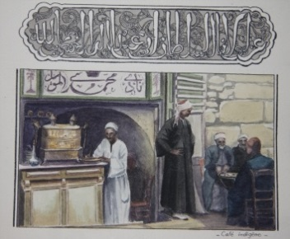
Flet, Paul. Egypte. Catalogue de Photos Stereoscopiques. . An exceptionally beautiful and well-done illustrated manuscript of travel in Egypt. Oblong, 8 by 6 inches, 21 by 15 cm. Unpaginated, with 61 leaves of card, text and illustrations only on the recto sides, and with majority of pages having some kind of illustration. With original watercolor illustrations of sights and attractions of Egypt, and headings are rendered with a lovely calligraphic hand. Occasionally the author produces Arabic calligraphy and ornament, also exquisitely executed. Some illustrations are mounted, while most are done directly onto the leaves. All are crisply precise and lovely; they include panoramas, night scenes, temples and mosques, statuary, the people -- vendors, bedouins, etc. Perhaps the subjects are not unfamiliar -- these are the things recorded by photographers and travelers from the nineteenth century to the present -- but the quality is high, and they have a cumulative effect in this home-made book. The creator of this album lavished care on all aspects of its production, and this extends to the slipcase and front board, in which the title and a simple decorative symbol is rendered with gold-colored leather pastedowns. While the use of binder rings to hold the album together might seem crude, it is complemented with a rounded piece of rusticated chrome metal that makes the end product both striking and somehow fitting of the topical matter contained within. Fine. Full Calf, bound with binder rings, and with a slipcase. (#002572) $2,800 £1,855

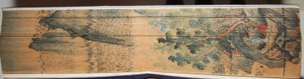
[Fore-edge Painting] Chinese Vertical Fore-edge Painting of Mountain Landscape, River and Two Men. . A scarce example of a Chinese fore-edge painting from the 1930s. The art of fore-edge painting was encouraged by William B. Pettus, a Catholic missionary and President of Catholic University in Peking, and students applied classic Chinese scenes to older books on the vertical axis, as opposed to the English horizontal norm. The books were then typically housed in highly decorative boxes with classic Chinese fabrics pasted to the boards and the inside folds fitted together with an intricate scroll-shaped cut-out and overlay and often sold via Dawson's Book Shop based in Hong Kong and Los Angeles. The scene depicted here is one familiar to lovers of Chinese landscape scrolls, with the mountains and bamboo forests such as one sees along the Lijiang River around Guilin. The image clarifies whichever way one fans the pages. The book itself, with a typical blue speckled paper binding, has a few minor tears to its thin, brittle paper. Its box has a few frays and edgewear but remains highly decorative. One of the two gun-shaped bone clasps is missing. The box measures 26 by 16.5 cm, 10.5 by 6.5 inches. Very Good. Elaborate Cloth Box. (#002252) $3,500 £2,320

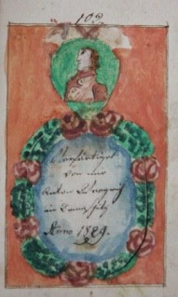
[Fraktur] Anton (?). German Folk Art Manuscript Breviary. A breviary, or devotional book, done entirely by hand, filled with simple, or naive, vignettes exemplifying the folk art traditions of rural Germany -- also known as "Fraktur" -- in the early nineteenth century. The cursive script is done by a steady, painstakingly meticulous hand, and thus attains the fluidity and regularity of calligraphy, although the shape of some letters is unlike more modern script and thus reading the text will be a challenge to many readers nowadays. The artlessness of the art is much of the appeal, but one would be wrong to think of the author/compiler as a mere bumpkin. The mere act of composing such a prayer aid would distinguish him from most of the population at a time when illiteracy was still rife. He also paginated his manuscript. There are 102 pages, each a compact 14 by 9 cm, or 5.5 by 3.5 inches. The manuscript ends with a most charming touch -- a flap that one pulls away from a wreath, and a cameo portrait, possibly of the author, above. The flap appears to have the author's name, Anton, and a surname which oddly can not be made out because the letters are alien to us. (#002024) $850 £563

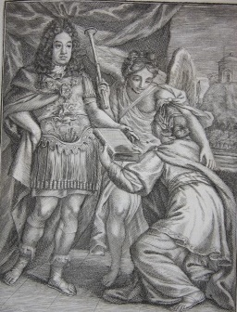
Gaio, Bartholomeo. Engraved by Bartholomeo de Petris. Series Chronologica Patriarcharum, Ducu, Judicu, Regu, Pontificum, Postreorunque Regu Populi Hebraici Ab Adam usque ad Agrippam Iuniorem eorum gesta breviter complectens cum suis Iconibus, Chronologico ordine, exposita Serenissimo Principi Francisco Farnesio Parmae Duci &c. Dicata a Bartholomeo Gaio. Roma: Superiorum permissu, 1724. First Edition. Scarce, with only two copies located on OCLC (at the Jewish Theological Seminary and the American Jewish University). 4to. Title, allegorical/dedicatory plate, intro (3 pp., text only on rectos), 113 plates (112 of which feature biblical figures or personages from the classical world), index, one page chronology from creation of world, title (for chronology on Ptolemaic rules of Egypt, intro (2 leaves), 15 plates with intaglio/numimatic illustrations of these rulers, index. Not in Brunet or Graesse. Contemporary vellum darkened around edges, and mild soiling, minor dings, elsewhere. Still exudes a freshness. Light scattered soiling within, and light toning. Generally leaves are clean and bright. Near Fine. Vellum. (#002558) $1,850 £1,225

A Garland of New Songs. Bess the Gawkie. Blythe was She. Yorkshireman in London. Pray Goody. Newcastle upon Tyne: J. Marshall. N.d., circa 1800. Folded sheet (or gathering) with eight pages containing the lyrics to five songs, and with woodcut. The sheet has edge toning and the edges are roughly cut. Very Good. (#002417) $50 £34

Girard, E. Album du Carnaval. Paris: Parfumerie Oriza de L. Legrand. First Edition. Scarce collection of twelve hand-colored plates depicting showgirls in then provocative costumes. N.d., circa 1880. 30 by 22 cm. The costumes are exotic and fanciful, and sometimes rather droll inasmuch as they involve adaptations of military uniforms and the like to the buxom, Rubenesque women who represented the ideal of the day. The colorful costumes include such things as that of the Royal Horse Garde of the S.A.R. le Khedive, Pierre Spadassin, Colonel du Royal-Regiment du Sphynx de S.A.R. le Khedive, Premiere Sultane, Colonel du regiment Highlanders, Commandant general des Policemen, Major du regiment Caiman de l'armee, etc. Only two copies located on OCLC (Harvard, Pennsylvania State University). Bookplate o Wilhelm Herzog [Duke] zu Brunschweig. A few light finger smudges in the margins; otherwise, plates clean and bright. Light wear to plain cloth binding. Very Good. Cloth. (#002576) $2,000 £1,325
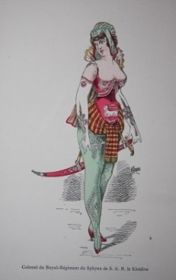
Guarini, Battista. Il Pastor Fido, Tragicommedia Pastorale: Ora in questa nuova impressione di bellissime figure in rame ornato. Amsterdam: Appresso Lodovico Elzevier, 1640. Book. 48mo - over 3 - 4" tall. 285 pp. Engraved title page + 3 additional full page engraved plates, with names of characters written underneath figures. Early miniature illustrated book version of Guarini's 1590 pastoral masterpiece, which is also one of the cornerstones of the Italian canon. The book measures 3.5 by 2 inches, or 8.5 by 5 cm. Printing possibly by Willem Blaeu of Elzevier. Final pages have worm hole, which diminishes to pinhole sized loss on text pages in two-thirds of leaves in lower margin. On a few leaves loss of a few letters but text remains readable. Other than this leaves are clean. Period vellum has some wear, blistering and limpness. Still an asset to the book. New attractive endpapers. Very Good Plus. Vellum. (#001244) $800 £525

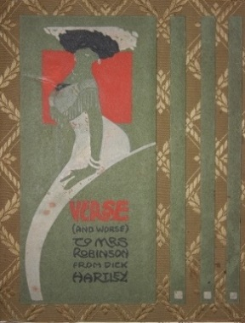
Hartley, Dick. [Illustrated Manuscript] Verse (And Worse) To Mrs Robinson From Dick Hartley You've Got a Lot to Answer For. . A stylish small collection of light verse and funny illustrations that together form a sort of love letter or card to a beloved, and presumably married, Mrs Robinson. Stylistically, the drawings are identifiably Art Nouveau, but coming at the tail end of that particular vogue, one can also see signs of the more streamlined Art Deco about to catch on. And there is a soigne sophistication to the whole production, with martini glasses ubiquitous, bespeaking of a Nick and Nora sensibility. Both the verse and illustrations are notable for their economy of expression, and in their artless simplicity, they demonstrate a real artistic flair. N.d., circa 1913, based on the single date written on one of the pages, although this date may refer to an earlier rendez-vous or the like. Only 14 pages of content, followed by blank leaves -- it is impossible to know whether the author considered the project complete or not. Binding of silk with felt mounted thereon, and illustration painted onto the felt. Silk is fraying at the edges and spine tips. Otherwise, clean and tight inside. Very Good. Hardcover. (#002562) $950 £630

[Heraldry] [Manuscript] B. Whippy & Son Crest Book. England. N.d., circa eighteenth century. With 161 leaves, the first 120 having crests, escutcheons and heraldic imagery on both the rectos, the last 41 leaves with imagery only on the recto, for a total of 281 pages with illustrative content. The heraldic symbols are all drawn with ink, generally six to a page, sometimes more, sometimes less, and always with a cursive handwritten caption of the individual or title to which it belongs. The symbols run the full gamut of heraldic figures, from animals, both naturalistic and stylized, to human figures, to crowns, weaponry, flora, stars, more abstract designs, etc. All are done with a sure and precise hand, making the log, for that is what it amounts to, a highly appealing manuscript, the purpose of which one can only surmise. All we know from the spine label and the front board pastedown label is that the book was of B. Whippy & Son, who we might assume were responsible for the creation of the book. Some soiling of the leaves, but generally the plates are attractive. Contemporary boards, with heavy scuffing but appropriate and desirable. Rebacked with a complementary green calf and in a way that is impressive and substantial. Newer endpapers. One paper repair. Very Good. Full Calf. (#002473) $2,750 £1,825
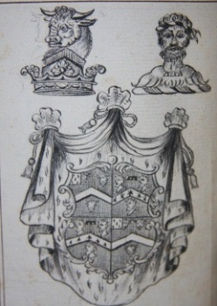
Des Koniglich Baierisch Militarisch Hohen St. Georgii Ritter Ordens Wappen Calender. Munchen: Fleischmann, 1817. 16mo. With 119 Engraved Plates, one folding, of portraits, coat-of-arms, and sometimes ornate decoration and imagery beside. A mix of line and stipple engravings. This is a collection of the escutcheons of German princes. Followed by almanac and calendar. The almanac part has death notices, not recent at time, that might have been included as a fee by noble families wishing to honor their forbears. The principle part of the almanac is a historic table with dates of ascession (coronation) and death of princes during mostly the eighteenth century. The binding is of added interest, being a red vellum. The binding has considerable wear, especially along the edges, and spine labels are chipped. Tight and mostly clean within, with FFEP partly loose. Two bookplates, both attractive, of Dudrea and Sumner Parker, who had a museum in Lutherville, Maryland in their home called "The Cloisters" which was bequeathed by them to the City of Baltimore. Very Good. Vellum. (#001873) $500 £330

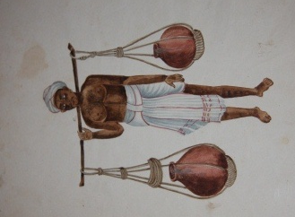
[Indian Interest] Collection of Seventeen Nineteenth Century Indian Costume Watercolors. . N.d, circa mid to late nineteenth century. These were watercolor illustrations of Indian characters in characteristic costume. The watercolors were produced for the English market as essentially souvenirs. Perhaps things that an English colonist might take back home at the end of his tour of duty, perhaps something that might be send to relatives back home, or perhaps even hung on the walls of his Indian bungalow. The drawings are on the naive side in their styling, and this is part of the charm. They are quite colorful and in detached form an excellent complement to the color plate costume books of the era. The paper is not a standard size, but they are all around 8 by 6 inches. There is some soiling to the off-white paper and a few minor chips or closed tears. They are all nonetheless fit for framing and very attractive. Now protected in heavy mylar sleeves. Very Good. (#002499) $800 £530

Japanese Flower Arrangements. . Early version of what later became a popular souvenir. This copy is all original pen and watercolor on a very fine, tissue-like paper or fabric which tends naturally to adhere to the neighboring leaf. With 80 leaves, with illustrations (or occasionally text) on both sides of the leaves. The coloring is generally a little on the crude side, with heavy use of a pink, a purple and a green. A few of the illustrations stand out, such as one featuring a monkey, another with a horse on a scroll painting. With a few holes in the paper. Many pages with creases, especially at the beginning and end and in the corners. Almost all the color of the wraps is chipped off, and minor loss along the lower edge of material. Good Minus. Wraps. (#002462) $1,800 £1,195

[Japanese Interest] [Meiji Culture] Scenes of Japanese Life. Tokyo. N.d., circa 1900. Leporello with 14 color woodblock plates. The scenes are various, depicting women, men and children, and scenes around food preparation , dining, pets playing, promenading, prayer, shopping, punishment, etc. Measuring 6.75 by 4.75 inches, or 17 by 12 cm, and each image is about 9 inches, or 23 cm, wide. Patterned silk with some edgewear. Very Good. Cloth on boards, leporello. (#002010) $500 £332

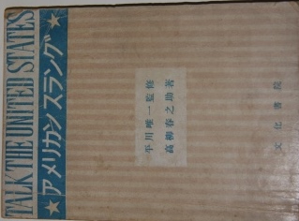
[Japanese Interest] Talk the United States. . N.d., circa 1946. 128 pp. Intended as a primer for Japanese in colloquial American English, the book is an unintended hoot, with many phrases and expressions mangled, sometimes just slightly, other times, beyond recognition. This is nowhere more evident than in the book's title, "Talk the United States", which is meant to mean, obviously, how to speak English, or more precisely, American English. Dip anywhere in this fairly dense reference and besides a good laugh, if one is a natural born English speaker, and you might get an insight indirectly into Japanese phraseology and expressions. It should be added that not all the expressions are off, and there are also some that may have been legitimate slang in the forties or earlier but now have fallen out of favor. This is an extremely scarce title, with no copies turning up on OCLC, and its value to students of Japanese culture and language is enormous. The pages are heavily toned and brittle. Some underlining and neat notes in pen and pencil. Still the text is entirely readable and these markings are not intrusive. Light foxing on the wrap covers. Closed tear in rear cover along joint about 1.5 inches long. Good. Wraps. (#002214) $850 £563

[Japanese Watercolor Album] Tokayi-do. Famous Places on the Tokaido. . 44 oblong pages of sublime Japanese watercolored panoramas, views and landscapes. A few of the images are double paged; all have a flow that provide a strong cohesion to the work, which qualifies as a pictorial essay. The treatment of buildings, topography, and flora is both impressionistic yet specific, and there is a dream-like quality that is powerfully seductive. The album measures 6.5 by 9.5 inches, 24 by 17 cm. The wrap covers are worn, with heavy edgewear, warping, soiling. The tissue thin leaves are folded over, and some of the folds have closed tears. While there is scattered light soiling on the pages, the images have their essential integrity intact. Very Good Minus. Wraps. (#002456) $1,350 £895

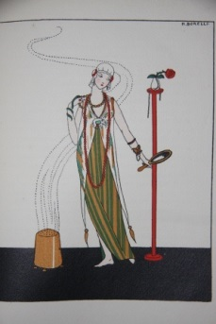
Jean-Meyan, Maurice, and Jean Socquet. Illustrations by M. & Z. Borelli, Vranska, G. de Colomes. Le Dessus du Panier. Paris: Louis_Michaud, 1914. First Limited Edition. No. 51 of 850 copies. Small 4to. 99 pp. With 22 color pochoir plates, mostly of fashionable women and luxury goods. Original wrappers. Colas 1542. Mahe p. 26. Age toned, but clean otherwise. Tiny, trivial corner crease to some pages (minor bumping). Near Fine. Wraps. (#002447) $900 £596

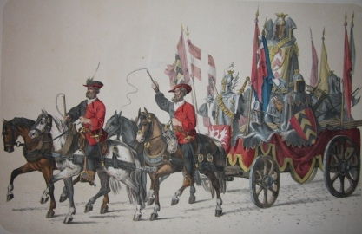
Jenny, Heinrich. Historischer Zug. Festalbum der Feier des Eintritts Berns. Bern: Stampflische Buchdruckerei, 1855. First Edition. 59 hand-colored lithographed plates, plus title, depicting a commemorative ceremonial procession, with colorful historic costumes and martial opulence. This parade marked the fifth centenary of Bern's entry into the Swiss Confederation. The oblong plates are large, measuring 13.5 by 19.5 inches, or 35 by 50 cm. Also a half-title and 5 pages of test, with a list of subscribers. Housed in a lovely modern quarter morocco clamshell box. Title and some plates with dust soiling and edgewear, as well as occasional spotting. Text pages have dampstain and foxing. One text page with closed tears and chips by a margin. Some edge creases. Very Good. Custom Clamshell Box. (#002435) $4,500 £2,980
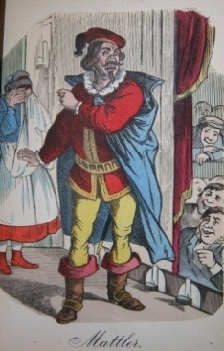
Jessen, H. Trachten aus Alt-Hamburg. Hamburg: B. S. Berendsohn; Jowien. N.d., circa 1850. With 105 hand-colored plates. This is more than double the number referred to in Colas 1547 or Lipperheide 809. No title page, and probably the front cover always served as the title. The original cloth cover has soiling and wear, with the fabric worn in the corners and extremities, and with some fading of the decorative border on the front cover. The binding, though, is tight, and the images within, with only the most occasional finger smudging or other soiling, are bright, vibrant and clean. (#002448) $2,400 £1,590

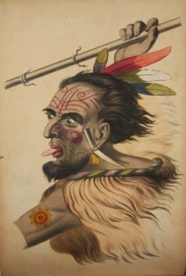
Josenhans, Joseph (1812-1884). Illustrations of Missionary Scenes, An Offering to Youth. Mayence: Joseph Scholz, 1850s. First Edition. N.d., circa 1850s. A scarce collection of twenty hand-colored plates of lurid, often grisly scenes of torture, sadism, mayhem, surely meant to shock and frighten children. Just the sort of imagery to garner an "R" rating, but in the era of "Slovenly Peter", the children were thought to have been made of sturdier stuff, undoubtedly. The images are divided among West Africa, India, New Zealand, the American Northwest and China. While the artistic execution may not be of the highest level, the vividness of the imagery more than compensates. In this copy the text leaves are heavily foxed or soiled, as an inevitability given the cheap paper stock used, while the plates themselves, on heavier stock paper, are only lightly soiled. The binding is tight, with more modern endpapers. The half leather is modern while the pebbled cloth boards is original. The cloth has some blistering, with more such spots on the rear cover. Very Good. Half Morocco. (#001848) $3,500 £2,320

Julliot, Georges. Cahier de Technologie. Nancy, 1941-1942. Folio, 14.5 by 9.5 inches, 37 by 24 cm. Unpaginated lined notebook, with 52 leaves containing content, illustrated and text, with material often, but not always, on both sides, and many blank leaves besides. Extraordinary student illustrated manuscript on printing, its technology, replete with lovely Art Nouveau decorative touches throughout. Sections are devoted to the history of printing, typography, metals used in printing, tools of the printer, corrections, composition, abbreviations, capitals, italics, alignment, colors, the art of printing, etc. and then such things as conservation. Besides the thoroughness of the manuscript on the sundry aspects of printing, the illustrations are disarming and quite literally invite the eyes to linger on the pages. Such school projects were a staple of French pedagogy, and for better or worse, French education has traditionally placed a premium on flair and style, at times, over substance. In the instance of this manuscript, the latter has not been sacrificed at the altar of the former, and the resulting product deserved the highest of marks on all accounts. Other than the headings, most of the text is written with a neat, albeit non-calligraphic, hand. Very Good. Quarter Leather, over Decorative Boards (a notebook). (#002557) $750 £497

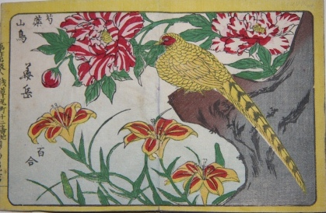
Signed Kagaku. Leporello of Twelve Views of Flowers and Birds. Tokyo, 1880. First Edition presumed. An exquisite Kachoga featuring a dozen color woodblocks of birds and flowers. The leporello measures, closed, 11 by 8.5 cm, 4.5 by 3.5 inches, and each of the twelve images is two panels and so double width. Each of the woodblocks is signed by Kagaku, or a name similar to that. It dates to Meiji 13. The images are Tree Peony (Mudan) and Silver Pheasant, Cherry Blossom and Swallow, Camellia and Pigeon, Plum Blossom and Japanese Bush Warbler, Cotton Rosemallow (Furong) and Sparrow, Chrysanthemums, Monkshoods and White Cuckoo, Lotus and Heron, Japanese Iris and Cuckoo, Japanese Camelli, Paperwhite and Kingfisher, Long-tailed Bushtit and Rose, Wild chrysanthemum, Bush Clover and Wild Goose, and Common Peony, Lily and Copper Pheasant. There are captions in Japanese, but the images speak for themselves. The covers, front and back, have a dampstain covering about a third to a fifth of the space with no effect on the images within. There is the lightest of soiling of the images at each end. Overall the images are vibrantly bright and fresh, including the images at the end. Very Good. (#002256) $1,000 £665

Kidd's Fashionable Library; or Mirror of Ton. Interspersed with Numerous Original Anecdotes of Popular Characters. Included are "The Book of Fashion", "The Book of Gentility", "The Book of Elegance", "The Book of Refinement", "The Lovers' Own Book", and "The Book of Courtship" London: W. Kidd. Book. 16mo - over 5¾ - 6¾" tall. Undated, circa 1830. Xrare, with only two copies turning up on OCLC Worldcat. With frontis plate and woodcut illustrations, two per section (with title and as tail piece at end). 36, 47, 36, 49, 32, 54 pp. In essence, six smaller books or pamphlets bound together, although it appears that these may have been originally issued as a single volume. Actual authorship of each installment is not given, but pseudonymous authors are One of "The Exclusives", A Member of "The Beef-Steak Club", A Lover of Nature, One of the Cognescenti, Amator, and Amicus Juventutis, respectively, with two of the sections, such as the first, Book of Fashion, supposedly "A Digest of the Axioms of the Celebrated Joseph Brummell, Esq." As the titles suggest, this is a mostly tongue-in-cheek etiquette primer as well as a wry send-up of the manners, mores and customs of fashionable society in Regency England. Tight, with some minor wear to red morocco. Interior clean. An attractive copy of a very scarce work. Very Good. Hardcover. (#001168) $900 £596

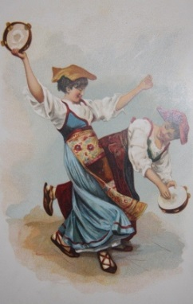
Kinney Bros. National Dances Vol. VI. New York. N.d., circa 1890s. 12ff and color engraved wrappers bound with string ties. Essentially a reproduction, in book form, of this tobacco company's cigarette cards depicting dances from around the world, including India, the American Indians, Poland, Egypt, the Tyrol, Ireland, Scotland, and on and on. On the versos are line drawings, and the rectos contain chromolithographs, generally six to eight reproductions of cards with a scenic backdrop of the land associated with a few of the dances. There are also three full page illustrations of particular dances from Spain and the Middle East, and the first page contains a poem by Moore entitled "Say What Shall We Dance?" with decorative letter devices. Scarce, with no copies located on OCLC. Cover worn and chipped in corners. Contents generally clean. (#002536) $275 £182

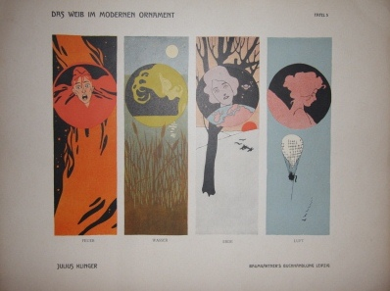
Klinger, Julius. Das Weib im modernen Ornament. Ein Vorlagenwerk fur alle Gebiete des Kunstgewerbes von Julius Klinger. Leipzig: Baumgartner's Buchhandlung. Second Improved Edition. N.d., circa 1902. 30 color plates, plus title plate, made of a chromotypographic process, with 140 subjects, 235 figures and heads, as set forth on the title plate. The designs are high Art Moderne, or Jugendstil, and they were intended for a broad range of applications. Listed on the title as applications are decorative painting, sculpture, drawings and other illustrations, vignettes, carpets, ceramics, book and paper decoration, metal, leather, wood, glass and textile work. The imagery rangers from the highly figurative stylized women to the luxuriant sinews of abstracted flower stems, from classical imagery to circus, equestrian, terpsichordian, music-making activities. The decorations are seductive and usher one's imagination to the time of their creation. The plates are oblong and measure 40 by 33 cm, 15.5 by 13 inches. Scarce work, with only five copies located on OCLC (only four listed). Lacking rear of original wrappers. Title has light soiling an edgewear, a corner chip, crease marks, one small heavier stain and a few minor closed tears in the margin. The other plates have light age toning, with a few creased in a lower corner. One plate, No. 16, with a more sizeable corner chip, not affecting the imagery, and a few plates with light edge dampstaining and short closed tears. Nonetheless, a handsome set of Art Nouveau plates that retain their basic visual integrity and panache. Very Good. Wraps. (#002408) $1,200 £795

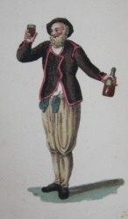
Koenig, Franz Niklaus. Nouvelle Collection de Costumes Suisses Representee en Quarante Planches, D'Apres les Dessins de M. F. N. Koenig. Paris: Chez Lefuel. N.d., circa 1820. 12mo. (12 by 7 cm, 4.5 by 3 inches.) 91 pp. With 40 exquisite hand-colored costume plates. Scattered soiling to the leaves. Corner creases to some leaves. Second to last leaf with tiny short tear center page. Red morocco itself has some soiling, but remains highly handsome, as does the slipcase, of this scarce near-miniature costume plate book. Very Good Minus. Full Morocco, With Slipcase. (#002434) $2,750 £1,825

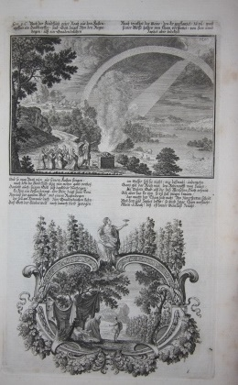
Kraus [Krausten, or Krausse], Johann Ulrich. Historischer Bilder Bibel. (Six Parts in One Volume) [Bound with] Biblishes Engel und Kunst Werk. Augsburg, 1700 and 1704. First Edition. A fine collection of highly detailed Baroque copper engravings. 165 plates in all, plus frontis plate for each of six parts and second work. 135 of the plates are part of the first work, 30 of the second. Folio, 13.5 by 9 inches, 34 by 22 cm. Elaborate Gothic Fraktur type on title pages. Each of the two works has several pages of text, followed by the plates. Frontis plates are all the same. Otherwise, the format is a larger rectangular image above, followed by verse, below which is a cartouche of varying size, sometimes with several images, and generally featuring a highly ornamental, often allegorical and figurative border. Occasionally the shape of the lower image is not literally a cartouche, or there can be more than one such shaped framing. Impressive is the sheer variety of the formations; yet with all the variety, they do read as a consistent ornamental element, and this element brings a baroque or early Rococo flair to the plates. Brunet III 696-7. A few minor chips along joints, and spine is scuffed and chipped. Occasional foxing and soiling within, never disconcerting. The foxing is heavier in the margins of the second work, for whatever reason. Still, plates are mostly clean and handsome. More modern endpapers and prelim blank leaves. Very Good. Full Calf. (#002564) $2,500 £1,660

Kurtzer Entwurff des lebens der Konige in Engelland/ Von der Zeit an/ Als die Sachsen und Angeln sich derselben Insul bemachtiget/ Bis schonen Kupffer-Figuren und Conterfaiten der Konige gezieret. Nurnberg: Johann Hoffmann, 1676. 12mo. (13 by 8 cm, 5 by 3 inches.) [18], 416 pp. With 27 copper engravings of the monarchs of England up to Charles II. Early German survey of English history, with quite attractive plates featuring escutcheons associated with the monarchs depicted. Soiling on the fore-edge. Very old fine handwriting on blank leaves in back. Vellum has some light soiling and a pinpoint hole on front joint. Strip of vellum that should crease over onto inside rear board is loose. Very Good. Vellum. (#001945) $450 £298

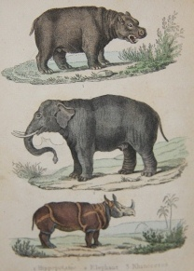
Lacroix, Paul. Petit Buffon Illustre. Histoire Naturelle Des Quadrupedes, Des Oiseaux, Des Reptiles, Des Poissons et Des Insectes. (4 volumes) Par Le Bibliophile Jacob. Paris: Didier, 1841. 12mo. (5" x 3.5", 13 by 9 cm.) With 62 hand-colored plates. Gumuchian 3551. Almost identical to the first edition of this work issued three years earlier except for addition in this edition of four wood engraved half titles. In any case, scarce to find an early children's Buffon such as this with the full complement of plates, not to mention with color. The first two volumes have a very light dampstain, nearly inconspicuous. Otherwise, light occasional foxing but generally clean. The contemporary calf spine head of volume 1 has chip and slight chewing. Elsewhere the leather has scuffs and light rubbing, but still attractive. The marbled paper slipcase is solid and attractive. Very Good. Quarter Calf, over Marbled Boards, with Slipcase to hold four volumes. (#002241) $1,200 £795

Laurence, John. The Fruit-Garden Kalendar: Or, A Summary of the Art of Managing the Fruit-Garden. [with] The Gentleman's Recreation: Or, The Second Part of the Art of Gardening Improved. [with] The Clergy-Man's Recreation: Shewing the Pleasure and Profit of the Art of Gardening (three volumes in one). London: Bernard Lintot, 1717 to 1718. First edition, second edition, and fifth edition, respectively. Three volumes in one. [4], vi, v, [1], 149, [3]; [xxii], 115, [1]; [x], 84 pp. ., Folding engraved frontispiece in first title; engraved frontispiece and 4 folding plates in second work; engraved frontispiece in third work. The three titles bound together in one octavo volume, measuring 8 by 5 inches, 20 by 13 cm. Period full paneled calf, rebacked calf spine, with five raised bands. A complete set of Lawrence's 'Art of Gardening' series. A fourth title (not present), 'The Lady's Recreation' was authored by Charles Evelyn. Marbled endpapers. Ownership inscription on blank preliminary. Some shelfwear to boards. Some light foxing but overall fresh looking interior. Very Good Plus. Full Calf. (#001309) $950 £630

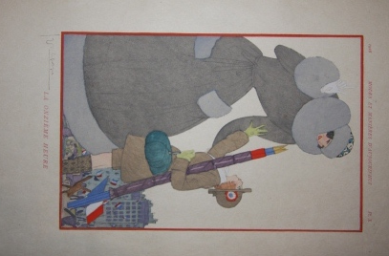
Lepape, Georges artist. Poems by Henry-Jacques. Modes et Manieres D'Aujourd'Hui. 1914 - 1919. Annees de Guerre Douze Guoaches de Georges Lepape. Douze Poemes de Henry-Jacques. Paris: Collection Pierre Corrard. Limited First Edition. No. 164 of 300 limitation on Papier du Japon. This was a part of an immensely popular series of pochoir sets depicting fashion between 1912 and 1922, with a single issue for the war years, which appropriately carries a more somber tone in its illustrations and verse than the other issues released in more carefree times. Not that some of the joie de vivre and fashion flair is entirely absent here. Most striking about the pochoirs is the simplicity and efficiency of their representations. Georges Lepape was one of the foremost practictioners of the pochoir process, the peer of Georges Barbier, and here he shows himself as fluent at the bittersweet and tragic as at the light and frivolous. The twelve poems and illustrations have a flow and progression and thus this serves as a small lens on the war years and their tumult on the domestic front. The title page has a narrow band of darkening along the left side. The folder has a modest closed tear of the paper along the spine fold or joint. The ribbon tie is missing from the front but present in the rear. The decorated paper used to encase the loose sheets has a few minor tears along the vulnerable folds. Near Fine. Folder. (#002231) $3,400 £2,250

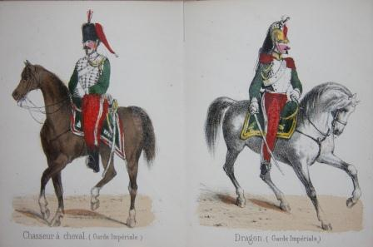
[Leporello] Album de L'Armee Francaise et la Garde Imperiale. Paris: Becquet Freres. N.d., circa 1860. With 25 costume plates, all tinted and then partially hand-colored. Uncommon item, with no copies being located on OCLC, yet recorded in important bibliographies: Colas 60, Hiler 16. Wear to the cloth covers. Discreet repair to the rear joint. One fold reattached. Very Good. Cloth. (#002300) $650 £432
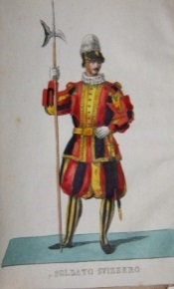
[Leporello] Costumi della corte Pontificia. Roma, 1846. First Edition. Leporello with 30 hand-colored images of Vatican costume, in addition to title with lovely colored decoration and cameo portrait of Pio IX. The last leaf is pasted to a folder, and the orange folder fits neatly into the original orange slipcase. Quite scarce with the all the parts present, and the imagery is sharp, bright and clean. Some wear to the joints of the leporello. Near Fine. Pebbled cloth folder and slipcase. (#002498) $650 £432

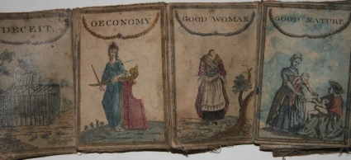
[Leporello] Fifteen Cartomancy Cards (?). . N.d., 18th century. With 15 hand-colored panels, possibly meant for a fortune-telling purpose or game, or possibly just a word game. The panels, or cards, are entitled "Friendship", "Gratitude", "Mask", "Deceit", "Oeconomy", "Good Woman", "Good Nature", "Coach", "Cottage", "Old Bachelor", "Letter", "Security", "Plenty", "Justice", "Hall". While also possible free-standing cards were mounted onto canvas later to create the accordian or leporello, the fabric appears as antique as the cards, and thus it is presumed that the format was either original or done virtually contemporaneously. While the images themselves are not naive in their execution, the overall effect of the piece is wonderfully folk art-ish, and as with much folk art, its meaning to its early users is a fascinating conundrum. The panels, or cards, are heavily soiled, with a light blue dye running over quite a few of them. The edges are worn throughout, and the edges of the cards are not fully pasted down anymore. Still a miraculously well-preserved oddity. Good. (#002522) $1,250 £828

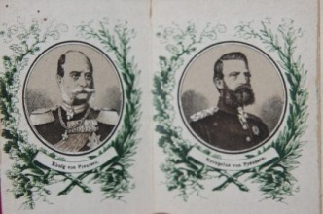
[Leporello] [German Political and Military Leaders] Wir wollen sein ein einig Volk. Uns trennen in keiner Noth noch Gefahr. Gut und Blut. Herz und Hand. Alles fur das Vaterland. Frankfurt: Ph. Frey & Co.. N.d., circa 1871. This near-miniature leporello (8 by 6 cm when closed), which features 26 cameo portraits of Prussian and German rulers and generals, was almost certainly issued as a commemoration and celebration following the Franco-Prussian War and the formal creation of an unified Germany. Most of the cameos, in fact, are of generals who served in that war or the earlier Austro-Prussian War. In any case, we can infer that the leporello dates to before 1873 because Kronprinz Albert von Sachsen ascended to the Saxon throne in 1873. Other cameos are of Wilhelm I, Kronprinz Frederick of Prussia, Prinz Carl of Prussia, Prinz August von Wurttemberg, Bismarck, Kriegsminister von Roon, General von Moltke, General von Voigts-Rhetz, General von Alvensleben II, Gen. von Krchbach, Gen. von Fransecki, Gen. von Azstrow, Gen. v. Manstein, Gen. Vogel von Falkenstein, Gen. von Steinmetz, Gen. von Goeben, etc. At least two of the folds of the diminuitive leporello have been repaired. Two of the cameos have rubbing on the card suface which partially lifts away some of the name captions. Minor chips to the paper pastedown on the front and rear, and in genreal there is age toning and wear from use, with the pull-out appearing not quite tightly suspended from the binder. Still, a scarce item, with no copies coming up in an OCLC search, nor online otherwise. Good. Leporello. (#002309) $225 £149

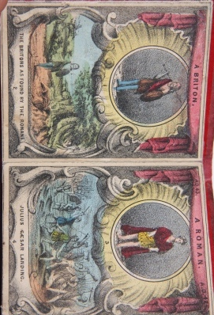
[Leporello] Panorama of English History. . N.d., circa 1840s. Leporello with 40 hand-colored panels, each with a cameo portrait, all but four of an English monarch starting with William I and concluding with a youthful Victoria, and below a vignette of a scene relating to that monarch, accompanied by a caption identifying the event. The first four panels depict a Briton, a Roman, a Saxon and a Dane. Very scarce, with no copies discovered on OCLC or COPAC. The mad-dash across over two millenia of English history has a folk art-ish charm while managing to capture quite minute detail in the vignettes. Clearly the target was a juvenile audience. Closed, the panorama measures 4.25 by 3.25 inches, 11 by 8 cm. It extends to 120 inches, or 300 cm. Some wear and light soiling of the red blindstamped boards. Light marginal soiling of the leaves. The final leaf has a rough edge, with minor loss of the margin. Very Good. (#002469) $1,950 £1,290

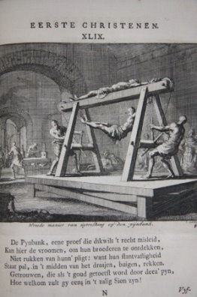
Luiken, Jan [spelled more commonly Luyken], illustrator. Pr. [Pieter] Langendyk and Cl. [Class] Bruin. Tafereelen Der Eerste Christenen, Bestaande in 92 Konst-Prenten van Jan Luiken, Berymt door Pr. Langendyk en Cl. Bruin. Amsterdam: Barend Visscher, 1722. 8vo. Unpaginated, but 92 leaves, with an illustration covering about two-thirds of every recto, for a total of 92 illustrations of lives of the early Christians, with plenty of gore, torture, and gladiatorial action to make the blood curdle and speak to those with an aversion for the purely devotional. The imagery is well within the tradition of high Dutch Baroque and in this, transcends the subject matter or not infrequently, ties in the subject matter with contemporary Dutch life. Not in Brunet or Landwehr. Some occasional light foxing but mostly clean. Tight. Calf boards appear to have had a coat of shellac or the like slapped on at some point, rendering an appearance not unlike plywood. Spine has dryness and rubbing along joints. Spine label with small chip. Very Good. Full Calf. (#001948) $1,300 £860

Maille, L. N. P. Chronologie des papes, des empereurs d'orient et d'occident, des rois de france, d'espagne, d'angleterre, des persecutions, des sectaires, des conciles et des ecrivains ecclesiastiques pour servir a l'histoire de l'eglise extraite de l'histoire ecclesiastique du Berault de Bercastel. Gand (Ghent) and Osnabruck, 1794 - 1800. A manuscript reference compiled and written by a Jesuit Priest during the French Revolution and Directoire period, when the working on such a work carried considerable risk. 8vo. [2], 307 pp. The author, M. Maille, both condenses an ecclesiastic history by Antoine-Henri Berault de Bercastel and carries it forward from 1721. The last 86 pages of this work are a detailed index compiled by M. Maille. All is written by a neat hand, making the book an object of beauty, independent of its content. The binding has light wear, with a small ding on the upper edge of the boards and scuffing of the leather. The leaves are clean and lovely. Very Good. Half Calf. (#002284) $750 £497

[Malo, Charles]. Hommage aux Dames. Paris: Louis Janet. L'Imprimerie de Richomme, 1825. 1825, based on Calendar for 1826 in the preliminaries. 24mo. 4.5 by 3 inches, 11.5 by 8 cm. [26], 156 pp. and with six engraved plates in preliminaries, in addition to title page vignette. (Plates not included in page count of prelims.) The cartonnage binding is neo-classical in design, with a geometric band around the periphery. The same design is on the slipcase, with an additional hand-colored engraving pasted onto the center of one side, and a smaller vignette, which now is essentially lost, on the other side. The main part of the book is an anthology of mostly poetry, and a few stories, written by the likes of Victor Hugo, Germaine de Stael, Lamartine, and many lesser known lights. This publication was an annual, and thus the saint's calendar in the front. Accompanying the plates are comparatively long explanations of what is painted and terse analyses. The age toning and foxing are throughout, heavy at times, with the plates afflicted more lightly. The slipcase and binding itself have a film of soiling, also acceptable. Very Good. Cartonnage, with Slipcase. (#002080) $225 £149
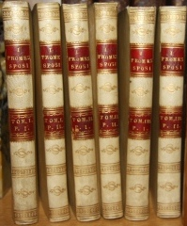
Manzoni, Alessandro. I Promessi Sposi. Storia Milanese del Secolo XVII. (Six Volumes). Firenze: Vicenzo Batelli e Comp., 1827. Early Edition. This set was published the same year the greatest of all Italian novels was first issued in Milan. (The version generally read today is the revision issued in 1842). Up to eight other publishers, in fact, issued the work by the end of 1827, these other editions being more or less pirated, as presumably this edition was. Nonetheless, the set is exceedingly attractive, with its supply, handsome vellum bindings and its plate per volume. Generally clean. Near Fine. Vellum. (#002443) $2,000 £1,325

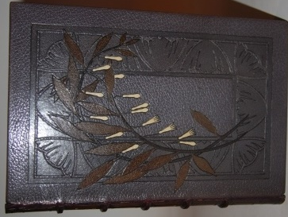
De Maupassant, Guy. Contes Choisis Le Loup. Hautot pere et fils. Allouma. Mouche. La Maison Tellier. Un Soir. Le Champ d'oliviers. Mademoiselle Fifi. L'Epave. Une partie de Campagne. Bibliophiles Contemporains. L'Academie des Beaux-Livres, 1891-1892. First Limited Edition Thus. 4to. No. 66 of limitation, the total number of which is undisclosed. Exemplaire de M. Henri Garon. The limitation page indicates that no copies were placed in commerce, and indeed this beautiful edition is scarce. Printed on a luxuriant paper stock, with impressed watermarks of floral patterns providing a sublime ornamentation to the leaves, and many illustrations, both interspersed in the text and as full page plates, some duotone, others a rich gouache palette. Gorgeous full morocco decorative binding by Canape R. G. with Art Nouveau floral design worked into the leather on the front board, and doublures of fine Chinese silk with floral pattern (mounted onto endpapers). Original wrap covers preserved and bound in. Tiny bookplate of Douglas Maxwell Moffat posted onto FEP. All housed in a sturdy slipcase that has morocco trim and marbled paper pastedowns on its boards. Near Fine in Slipcase dust-jacket. Full Decorated Morocco. (#002546) $2,500 £1,656

Mills, Alfred. Costumes of Different Nations, In Miniature, from Drawings by Alfred Mills. With Descriptions. London: Darton, Harvey & Darton, J. Harris, 1814. First Edition. 32mo, 6.5 by 6 cm. 96 pp. With many costume plates, black and white. Scarce. Tiny chips to leather by upper spine tip. One small discreet paper repair on text page. Inscription on rear blank. Very Good. Full Morocco. (#002596) $400 £265

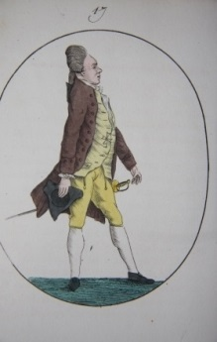
Mimique. L'Art de Connaitre les Hommes sur Leurs Attitudes, Leurs Gestes et Leurs Demarches; D'Apres Lavater; Avec Trente-Deux Planches Coloriees. Paris: Chez Saintin, 1826. 12 mo. 5.5 by 4 inches, 14 by 10 cm. [4], 42 pp. 32 hand-colored plates. Scarce, with only three institutional holdings of it located on OCLC. While the work might have been intended as a guide to the "science" of physiogamy, its value to us is in the insights it offers about the unspoken language of expression and gesture and how it might have been intrepreted at the time. Thus we are shown that this particular appearance indicates a person incapable of introspection, this other, the confusion of an incorrigibly heartless, dishonest individual. We might reject the connection between the appearance and the character type, but the belief at the time would certainly have informed actors at the time in how to convey the personality of the characters they were playing, and in everyday life average people had to have consciously sought to mold their behavior to present themselves flatteringly in accordance with the principles set forth in such a work. So this modest entertaining book enriches our understanding of manners and culture of the day beyond that provided in costume anthologies and other works. With the contemporary wraps. Minor soiling and wear. Very Good. Wraps. (#002570) $1,400 £930

[Miniature] The Book of Common Prayer, and Administration of the Holy Communion, According to the Use of the Church of England, Together with the Psalter or Psalms of David. Oxford: University Press Henry Frowde. Miniature, finger-sized and shaed prayer book, measuring 9 by 2.75 cm, or 3.5 by 1 inch. N.d., circa 1890. [1], 76 to 599 pp. The leather is rubbed and scuffed but remains handsome, with gilt title clear. Corner wear to narrow leaves. FInal leaf with tiny chip by upper hinge, with no loss of text. Light red ink inscription on prelim blank dated 1892. Good. Full Morocco. (#002297) $100 £67

Morris, Beverley R. British Game Birds and Wildfowl. Illustrated with Sixty Coloured Plates. London: Groombridge and Sons, 1864. Measures 12 by 10 inches, 32 by 26 cm. iv, 252 pp. With sixty lithographic color plates, all finished by hand. Occasional light foxing. Plates are bright and fresh. Rubbing to contemporary red morocco along joints, extremities, edges, corners. One quarter-sized splotch on marble pastedown. Very Good. Half Morocco. (#002387) $2,600 £1,725
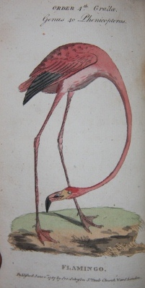
The Natural History of Birds; Containing a Variety of Fact, Selected from Several Writers, Illustrated with Upwards of One Hundred Copper-plate. In Three Volumes (Three volumes bound in one). London: J. Johnson, 1786. First Edition. A splendid eighteenth century ornithological work with 116 hand-colored plates. 12mo. 7 by 4", 18 by 10 cm. 91, [1], 3-77, [2], 72, 56, 83, 233, [1] pp. The illustrations are simple, straightforward and accurate, and the coloring was done with care and sensitivity, creating uniformly lovely and reliable images of birds of all types found around the world. The accompanying text describes each of the species and is full of quaintness and charm. The plates and text are generally clean, with light age toning and occasional soiling and/or foxing few would find troublesome. Modern calf with marbled endpapers. Very Good Plus. Full Calf. (#002188) $3,200 £2,120

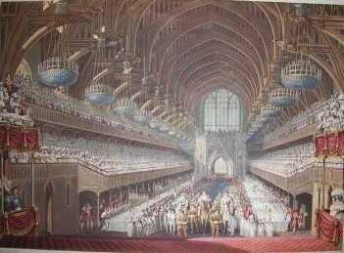
Nayler, Sir George. The Coronation of his Sacred Majesty King George the Fourth solemnize in the Collegiate Church of Saint Peter Westminster upon the Nineteenth Day of July MDCCCXXI Published by his Majesty's Especial Command. London: Samuel and Richard Bentley. First Edition. Large folio, 22.5 by 16.5 inches, or 57 by 42 cm. 13 hand-colored plates, plus large hand-colored illustration on title to plate section of the book. This volume was followed by a separate volume commemorating the same event issued three years later (1827), and the these two volumes were later collected, along with yet another work (Whittaker's plates of the same event) into a single volume in 1837, See Tooley 343. Calf is heavily scuffed in corner triangles and a few other spots, and rubbed particularly along hinges, with abrasions on the spine and a few spots of crud. Minor margin soiling of a few plates. A number of short closed tears in the margins -- most have been repaired but traces of them still discernible. Generally the plates are bright and clean, and this remains a collection of magnificent, exciting plates. Very Good. Half Calf. (#002404) $2,500 £1,656

Nietzsche, Friedrich. Also Sprach Zarathustra. Leipzig: E. W. Fritzsch, 1886. First Edition. 8vo, 24 by 16 cm, 9.25 by 6.50 inches. 114, [4], 113, [4], 117 pp. First edition, second issue, in which the first three of four parts of Nietzsche's abstract novel were collected, with new title page printed by C. G. Roder, and published in late 1886. With all points mentioned by William H. Schaberg in "The Nietzsche Canon", p. 218 other than wraps now replaced with very handsome half calf over gray boards binding, and in part three, leaf with Inhalt (table of contents or p. 119) not included. In essence, the parts herein are probably of the first issue other than the addition of half-titles and the like. For instance, the "1" on the bottom of the first page of Part III was weak or non-existent in many copies of its first issue and thus is the case here. Extremely scarce early Nietzsche in any state, owing to the checkered, conflict-ridden publishing history of this and other works by Nietzsche. It was during the issuance of "Also Sprach Zarathustra" that Nietzsche had a complete falling out with his publisher, Ernst Schmeitzner, who issued the first three installments of the work separately between 1883 and 1884, before going bankrupt in 1886. Fritzsch, who had published for Nietzsche earlier, ended up buying up the full Nietzsche catalog and stock from Schmeitzner and was the first to issue the three parts together in 1886. (The fourth and final installment of "Zarathustra" was first distributed in May 1885 (45 copies) but was not issued to the public until March 1892.) Other than one small stain on rear cover and a light scuff here or there, the half calf over boards is in fine condition. A few minor chips on original title page, and since all leaves were not cut even, there are inevitable tiny closed tears or chips on those leaves that protrude ever so slightly more than the others. Some browning of leaves, most pronounced on the title. Otherwise tight and clean. Fine. Half Calf. (#001409) $4,750 £3,145

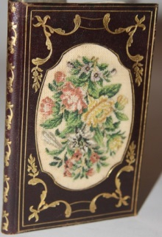
Antique Note Pad Bound in Full Morocco with Needlepoint Centerpiece on Front and Rear. . N.d., circa mid to late nineteenth century. Probably French, and unquestionably French Rococo in style, with its gilt swag decoration on the boards and eighteenth style needlepoint bouquets forming the primary decorative element front and back. As typical of small note or memo pads, a pencil slides through leather loops on the side to hold the book closed when not in use. The exquisite notepad measures 13 by 7.5 cm, or 5 by 3 inches. Minor wear, all in keeping with age. Near Fine. (#002138) $200 £135

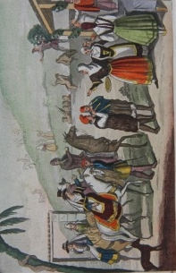
Le Nozze di tutti i Popoli dell'Europa. Milano: Presso Giuseppe Pozzoli, 1831. First edition. Very scarce, with no copies located on OCLC. 12mo. 12.5 by 8 cm, 5 by 3.25 inches. [5], 137, xvi pp. Seven hand-colored plates, plus color vignette on title page. No author given, although a preface credits Giulio Ferrario as the source for the fourth and last part of the work (it isn't clear what exactly constitutes this). Survey goes back to the classical world of Ancient Greece and Rome. The misconceptions and stereotyping are part of the interest. A final section, separate from the primary work, is an almanack of sorts. Elaborate blindstamping to boards, with gilt Greek key decorating spine and a gilt floral band as border to the boards. Slipcase with same design, front and back, and floral band to sides. Scattered mild foxing, as inevitable given paper stock used at time. Very Good. Romantic cartonnage binding, with slipcase. (#002571) $1,450 £960

Ogawa, Enson, editor. Works within by Utagawa Kuniyoshi, Utagawa (Ando) Hiroshiga, Utagawa Toyokuni, Kaisai Yoshitoshi. Collection of Nishikie on History, Geography, and Customs [Rekishi chiri fuzoku Nishikie bunko] (5 volumes). Tokyo, 1917-1920. The set of five volumes contain in total 174 wonderful color woodblocks. The set was surely intended at least in part for the tourist market, and thus its component volumes include some of the justly most famous books and illustrations produced in Japan. Among the volumes is the classic work by Utagawa Kuniyoshi (1797-1861), Seichu Gishi Den, or Stories of the True Loyalty of the Faithful Sumurai, with 50 plates, Utagawa Hiroshiga's "The Story of the Revenge of the Soga Brothers" or "Soga Monogatari", 30 plates, as well as from his "One Hundred Famous Views of Edo". or Meisho Yedo Hiakke, 28 plates, "Kokon Meifuden", or "Anthology of famous women of all ages" by Utagawa Toyokuni (1769 - 1825), 30 plates, and finally " Kinsei kyo ogiden" or "Biographies of Modern Men" illustrated by Kaisai Yoshitoshi (1832-1892). These volumes may be abridgments of the originals, but all of them offer plates that dazzle with their color, and the print quality is high indeed. With the cross-section of martial and domestic subjects, lovely panoramas and human studies, the Westerner could enjoy a balanced cross-section of the high points of Japanese color woodblock tradition, a tradition that strongly influenced Western artists of the late nineteenth century and beyond, including Van Gogh, Whistler, and many others. The covers all have some wear and light soiling. Generally the plates are bright and clean. The cloth folio which houses the five volumes has sunning and wear but remains structurally sound. A sixth volume was issued by Ogawa, but it should be noted that the five volumes here fit snugly into their folio and thus the set here is complete. Very Good. Wraps, with a cloth folio. (#002540) $1,600 £1,060

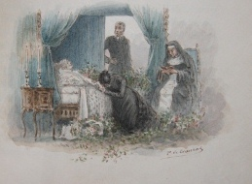
Ohnet, George. Original watercolors by P. de Crauzat. Le Docteur Rameau. Paris: Paul Ollendorff, 1889. Limited First Edition. No. 4 of 8, and one of five on Japanese vellum. 8vo. 345 pp. An extraordinary copy illustrated at the beginning and end of each chapter with original watercolors by de Crauzat, who signed his illustrations. Together with a full page title watercolor, de Crauzat did 25 for this work. These illustrations capture perfectly the sentimental romance of the story itself, and each lays fair claim to being a miniature masterpiece. For an artist as accomplished as this de Crauzat to undertake such a project is truly unique, and thus this copy is special in the wider universe of published fiction literature. The binding, too, is an object of beauty with inlays of floral detail into the gilt spine decoration. The half green morocco has one flaw -- the front board has been reattached at the hinge, and the repair is apparent to the eye. Minor wear to the binding elsewhere. FFEP is cracked by hinge. Otherwise, interior is clean and tight. Very Good. Half Decorated Morocco. (#002331) $2,800 £1,855

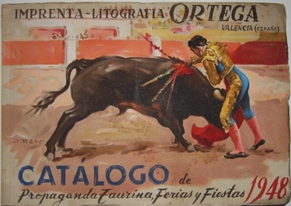
Ortega, Imprenta-Litographia. Catalogo Muestrario de Carteles, Cartelitos, Cabeceras, Prspecus y Billetes de Propoagand Taurina, Ferias y Fiestas. Valencia, 1948. Oblong 4to. 43ff in color wrappers. Splashily colorful trade catalogue from lithographic printer specializing in cards, tickets, programs and posters dedicated to bullfights and local fairs and fiestas. Much of the content is brilliantly illustrated promotions of bullfights, with flyers, posters and the like tipped in, generally two or three pasted onto the same base leaf. Samples which in practice might have been printed in varying sizes, often much larger than in the catalogue, they capture the thrill, ritual and spirit of the sport. The pages with tickets and some other items are less eye candy but no less useful documents of the material paraphernalia of the sport, and reminders too of the manifold commercial aspects of an entertainment business. Quite scarce, with the only copies surfacing on OCLC single copies from 1945 to 1960 of catalogues from the same company that are housed in the Biblioteca Nacional de Espana and a 1954 catalogue at the Ibero-Amerikanischen Institut. Very Good. Wraps. (#002442) $850 £565

Penaninski, Baron pseudonym, editor. Count Sketchimoff, also pseudonym, author. A night at Ben Rhydding with Signor Hydrositzandouche. Edited by Baron Penaninski ; with fourteen sketches chiefly illustrative of the hydropathic treatment by Count Sketchinoff. Leeds: Office, Ben Rhydding for the Benefit of the Hospital at Ilkley. J. F. Masser, lithographer, 1855. First Edition. Scarce send-up of hydrotherapy and more broadly, medical therapies and their practitioners and promoters. Only copy located on OCLC in the British Library. Oblong, 21 by 28 cm. Unpaginated, 53 pp. A mix of line drawings/cartoons and comical verse. Wraps are creased, chipped, and somewhat rough, while rear holding on by a thread. Leaves within are heavily toned around perimeter but otherwise clean. Good Minus. Wraps. (#002595) $600 £397

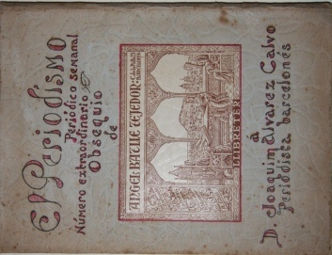
El Periodismo. Periodico semanal Numero extraordinario. Obsequio de Angele Batille Tejedor. A D. Joaquim Alvarez Calvo, Periodista barcelones. Ano I, Num 1 [Including] Humorisme Suplement de la tradicio. Barcelona, 1946. Large 8vo. [24] pp plus [12] pp Supplement, laid into illustrated folder with flap. Title drawn and colored on cover. Centerpiece of cover is a bookplate for Angel Batile Tejedor which depicts a Medieval library scene. The text of the primary work is rendered with a calligraphic hand in black and red with some naive foliate ornamentation in green. The text is a near bullet point history of Spanish, and Catalonian, magazine publishing. The second work is profusely illustrated with red and black cartoons. These are all original and drawn by a member of the Batille family. The two seemingly unrelated works are tied together with the final cartoon which carries the caption "El Periodismo en Barcelona por H. Alvarez Calvo", the writer's 1940 study. (#002520) $500 £332

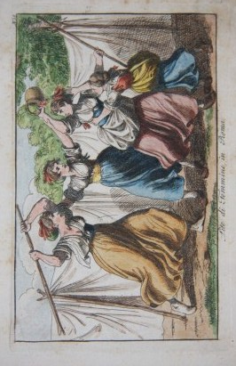
Pinelli Romano, Barlotomeo. Nuova Raccolta di Cinquanta Costumi Pittoreschi. Roma: Giovanni Scudellari, 1817. With 50 hand-colored plates depicting genre scenes that provide a window onto the street life of Southern Italy in the early nineteenth century, which did not lack for color in its drama, its daily rhythms, its joys and sorrows. This is the Verismo Italy of Verga, even if it is not Sicily that is being shown. Lutists, dancers, peasants, scriveners, soldiers, beggars, washerwomen, hermits, knife fights, clawing women, bear dancing, shepherds, public punishment, bocce players -- these are among the many things depicted. Generally this collection is found only in black and white; the color enriches in particular by compensating for the vagueness and simplicity of the facial features of the figures. It should be said, though, that the faces have a dignity that one finds in statue. The color, above all else, invests the pictures with visual excitement. Colas 2379. Lipperheide 1264. The plates are of modest dimensions, measuring an oblong 8.5 by 5.75 inches outermost (21 by 14 cm), and 6 by 3.5 inches in their actual pictorial image. Moderate to heavy foxing in the margins of the plates. Nonetheless an appealing copy. Good. Quarter Morocco. (#002012) $2,750 £1,825

Rawstorne, Lawrence, Esq. Gamonia: or The Art of Preserving Game; and An Improved Method of Making Plantations and Covers, Explained and Illustrated. London: Rudolph Ackermann, 1837. 1st Edition. Book. 8vo - over 7¾ - 9¾" tall. 208 pp. Includes errata page. With 15 hand-colored plates, drawings "taken on the spot". Gamonia was intended as a guide or handbook on the maintenance of a hunting preserve, or how best to set up farmland or woodland so as to optimize hunting or shooting potential. Written in a comparatively breezy or conversational style, its words of advice are still appreciated and read -- it remains a valuable reference, a classic on the subject. But without question the work is treasured above all else for its wonderful plates depicting sportsmen of the Regency Era -- plates much reproduced, framed and emulated. The orginal contemporary morocco has attractive border decoration on the boards, the gilding of which remains bright. Some wear to corners, rubbing and wear along edges, but boards are overall well-preserved. Also contemporary spine, with title written across length, but spine has been restored and signs of dryness, cracking and resulting unevenness are readily apparent. Binding is tight. Offsetting, as to be expected, from plates. Pages are generally clean. Some light soilage on endpapers and some plate margins. Pictorials if plates themselves are all bright and crisp. A very good or better copy overall. Very Good Plus. Hardcover. (#001137) $1,700 £1,125

Jules Renard. Illustrations by Pierre Bonnard. Histoire Naturelles. Paris: Ernest Flammarion. Imprimerie Hemmerle, Petit et Cie.. N.d., circa 1910. 12mo. 346 pp. Although Renard's work inspired a number of famous artists, Bonnard's simple, deliberately naive-styled line drawings perfectly match the highly economic whimsy of the prose. Original wraps are bound in. The binding is particularly lovely, with half green morocco and boards covered with a modernist abstract design. Minor rubbing along the joints. The pages are age toned. Overall, a tight and clean copy. Very Good. Half Morocco over Boards with Decorated Paper Pasted Down. (#002149) $300 £199

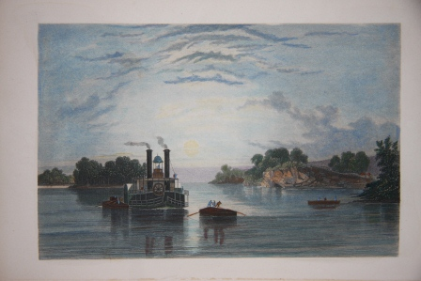
Richards, T. Addison. American Scenery, Illustrated. New York: Leavitt and Allen, 1854. First Edition. A special of this work, with its 32 plates hand-colored, unlike the typical copy. 4to, 9.5 by 8 inches. 310 pp. Large, light dampstain affecting first few text leaves, then fading. Other soiling and light foxing on a few of these leaves, and a few early plates having light foxing. Some later plates with marginal finger smudging, and one with a small light dampstain. The tissue guards are slovenly -- a good number appear to have been tipped in later, and many are creased and a nuisance. Most of the contents otherwise is clean. Blindstamped calf binding chipped in upper spine extremity and some goupiness in upper front joint. Otherwise light wear. Very Good Minus. Full Blindstamped Morocco. (#002451) $1,600 £1,060

Robert, Gaston. Aimable Enfance: Scenes Gaies et Morales, Dediees Au Jeune Age. Paris: Nouvelle Librairie De La Jeunesse; Louis Westhausser, Editeur. 4to - over 9¾. Book. Circa 1900. 24 pp. Illustrations on every page, seven of which are in color, chromolithographic, 5 of these being full page, and color illustration on cover. Stunning book, and copy is pristine. Fine. Decorated Cloth. (#000714) $225 £149

Rooke, Emily. Album with Original Watercolors, Hand-Colored Cut-Outs, Costume Plates, etc. . N.d., circa 1840, with perhaps a few items from later. Presumed the work of Emily Rooke, whose name is written on the FFEP in a contemporary cursive. An early, Biedermeier era English album of miscellaneous artwork, some of which is original, others, printed. In all, there are 65 pages of illustrated content, with ten of those containing original artwork, and several other pages with hand-done borders or ornamentation. Most of the printed illustrated matter is hand-colored. The original content is tilted to butterflies and flowers, with one particularly handsome color drawing of a young boy holding a cane and hat. Costume is certainly the emphasis otherwise, with a number of attractive views as well. Perhaps the most striking of the illustrations is a hunting scene created by a number of intricate cut-outs. Another noteworthy item is a cut-out portrait of the sculptor Antonio Canova with what appears to be his actual signature underneath. Rebacked, with the original spine, most of which has survived, laid on. Wear to the edges. A few cut-outs within have suffered minor losses. Very Good. Blindstamped Calf. (#002531) $875 £580

Rosa, Salvatore. Satire di Salvatore Rosa Dedicate a Settano. Amsterdam: Presso Severo Protomastix, 1696. First Edition thus. N.d. Circa 1690. 12mo. 160 pp. Woodcut ornament on title. (Brunet IV 1390. 12mo. Gamba 2071) Contemporary vellum. Front joint repaired. Slight separation of lower rear joint. Restoration to upper corner of leaf pp 93/4. P. 107 with awkwardly cut margin. Considerable toning especially around text, but overall fine other than issues mentioned. Rosa is best known as a landscape painter but he also in his lifetime has a considerable reputation as a poet. His eventful, picaresque, and now mythologized life centered at various times around Naples, Rome and Florence. As a champion of artistic freedom, Rosa rejected the then prevalent patronage system in the artworld. In the satires Rosa attacked aspects of the music and art scene, and the most famous of the satires, "La Babilonia", took daring swipes at the clergy, leading to its placement on the Vatican's Index of prohibited works. Near Fine. Full Vellum. (#001803) $600 £397

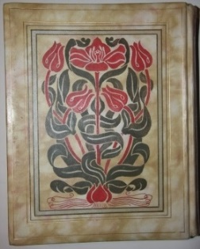
Ruskin, John. Notes by Mr Ruskin on His Collection of Drawings by the Late J. M. W. Turner, RA. Exhibited at the Fine Art Society's Galleries; Also a List of the Engraved Works of that Master Shown at the Same Time. Illustrated with Thirty-Five Plates, and a Map Indicative of the Places in the British Isles Illustrated by Him. London: Chiswick Press, for The Fine Art Society, 1878. First Edition. An original painted vellum binding done with a period-correct arts and craft aesthetic! 4to. [2], 188 pp. TEG. Marbled endpapers, surrounded by gilt lines and floreate corners. Scattered light fox marks. The vellum is bowed, as typical. Regardless, an outstanding artistic binding that remains in great shape. Near Fine. (#002559) $750 £497

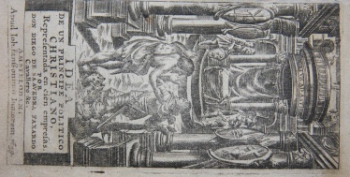
de Saavedra Faxardo, Don Diego (1584-1648). Idea de un Principe Politico Christiano Reresentada en cien empresas. Amsterdam: Ioh. Ianssonium Iuniorem, 1659. 12mo., 14 by 8 cm. [24, ]835 pp., with 103 emblems plus title illustration sharply and minutely etched, and including title. This is more than title suggests. Text proper has in actuality 101 symbols and thus emblems, plus there is an additional emblem in the prelims and one at the end of the work. This is a Latin translation of the Spanish original. The contemporary vellum has some soiling, especially where creased on the spine, but still attractive and a bright patina survives. A light dampstaining affects some leaves. Overall the leaves are Pages 793/4 have an archival repair of a smallish closed tear. Very Good. Vellum. (#002169) $1,450 £960

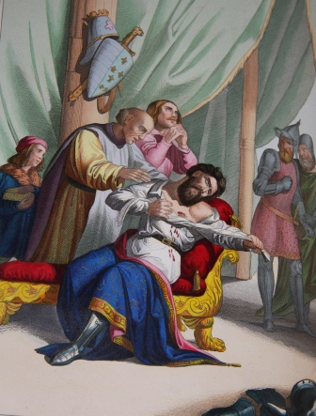
C. Sabattini, C. Rusconi, etc. Galleria Storica dell'Italia Contenente in Cento Intagli Miniati i Fatti Piu Notabili Avvenuti nel Corso di X Secoli Illustrati di Descrizioni e Notizie (Two Volumes). Firenze: David Passigli, 1845-6. First Edition. Uncommon title with 100 bright and hand-colored plates depicting major figures and events of Italian history. Each plate accompanies generally eight to twelve text pages relating a tale or biography of the figure(s) depicted. The articles are ornamented with lovely ornate borders which vary in color and design from one piece to the next. The work itself was issued at a time when Italian consciousness was finally being roused with the first rumblings for unification, which would finally come to fruition two decades later, but it is significant that in this work the heros and heroines highlighted come from all over the Italian peninsula, including Naples, Venice, etc. then separate kingdoms, principalities, or under Austrian or Church control. The beauty and scale of this two volume set ensured that it would be treasured and also that it would be lovingly consulted repeatedly to learn about or re-acquiant oneself with the rich heritage of Italian legends. The plates themselves are colored in an interesting manner, with the background and secondary characters and scenery colored lightly, with a thin layer, and the focal point featuring deeper colors, enriched with gum arabic, and the effect of this two-fold approach is to render almost a depth of field. This copy of the set is clean throughout, with both the plates and text leaves nearly spotless. The red morocco was bound by Stikeman & Co. of New York. It has some rubbing along the joints and edges, with heavier wear in the corners. Nonetheless the binding remains handsome and complements well the luxuriance of the content. Near Fine. Full Morocco. (#002204) $3,750 £2,485

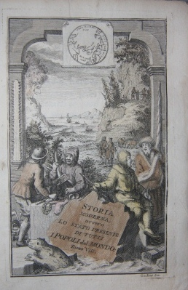
Thomas Salmon. Lo Stato Presente di Tutti i Paesi, e Popoli del Mondo Naturale, Politico, e Morale, Con Nuove Osservazioni, e Correzioni degli Antichi, e Moderni Viagiatori. Volume VIII. Dell'Imperio della Moscovia o Russia; dei Regni di Svezia, di Danimarca, e Norvegia, e della Groenlandia. Venezia: Presso Giambatista Aleizzi Q. Gir., 1738. Unpaginated Prefazione, 446 pp. Copper engraved maps, portraits and animal studies, the frontis being a general map of Europe, and 16 other illustrations as called for, most folding. Maps generally very well preserved, with minor tearing where bound in. A light dampstain runs through the Greenland chapter. Former owner from way back made a few small sketches in old sepia nib and tried their hand at applying watercolor to frontis and portrait. The coloring was not completed but is not bothersome. While only offered here is Part Eight, this functions fine as a standalone volume. Very Good. Vellum. (#002474) $775 £515

Scamozzi, Vincenzo; Batista Pittoni, illustrator. Discorsi Sopra L'Antichita di Roma di Vicenzo Scamozzi Architetto Vicentino Con XL Tavole in Rame. Venetia: Appresso Francesco Ziletti, 1582. First Edition. Folio (29 x 20 cm, 11 by 8 inches) , 40 double plates, with early color applied to 16 of them in varying degrees. Collation: engraved title, A8, t1, B8, 40 double paged plates, blank. First part contains index of buildings and places depicted. After dedication, three brief essays: "Della edifcatione di Roma, & del vario accrescimento del quella, De' Colli di Roma & dell'etimologia de' nomi loro, and Delle regioni di Roma, & de' termini--. Then there is a description of the first plate. At the end of the book there is an errata page. The color in the plates so embellished is washes of greens, yellowish browns and pinks mostly. While most of the color is applied to lawns and is never carried through and through, it still does add to the beauty and fullness of the images, as well as capture the atmosphere of the haunting locales such as thery surely were before packaged and overrun by the hordes of tourists. A rare work, this is usually encountered in the 1583, not 1582, edition, as here. Dedication to Giacomo Contarino from Giralamo Porro, publisher, dated 1581. One of the earliest works to direct attention and appreciation towards the ruins in Rome. The illustrations prefigured and influenced Piranesi and others. Sites illustrated include the Via Sacra, the Coliseum, the aquaduct, etc. Mortimer 466. Brunet V 180. Not in Gamba. Scamozzi (1556-1616) was a Venetian architect. A student of Palladio, he completed projects unfinished when Palladio died, including the Teatro Olimpico in Venice. He later designed the Procuratie Nuove on the Piazza San Marco, and as an author, besides this work, he wrote "L'Idea dell'Architecttura Universale", 1615, which became a classic on architectural theory, deeply influencing Inigo Jones. Indeed, Scamozzi is regarded as "the intellectual father of neo-classicism" by Rudolf Wittkower. Porro (1520 possibly -1604 possibly) was a well-known Venetian engraver who, among other things, did the plates for Porcacchi's "Isole piu famose del Mondo". Giacomo Contarini (1536-1596) was a member of one of the leading Venetian families at the zenith of the City's international influence and power. The family produced six doges. Giacomo himself was a noted bibliophile whose sutdy functioned like a private museum. Other aspects of the book: many ornamental figures throughout, including head and tail-pieces, and engraved initials. Modern calf in Cambridge style, exquisite in all respects, with raised bands and red title label on spine. Some light marginal soiling throughout. Title has inked swiggles at top and bottom edge. Plate III with minor closed tear in lower margin. Bookplate of Victor Albert George Child Villiers, 7th Earl of Jersey, pasted onto FEP. Villiers (1845-1915) was an English banker, conservative politician and colonial administrator. His family estate outside of London, Osterley Park, is now a museum owned by the National Trust. Villiers had a formidable collection of books on architecture. Fine. Full Calf. (#001532) $16,000 £10,600

Schlichtegroll [Adolphe Heinrich Friedrich], ed. Gallerie altteuscher Trachten, Gebruche und Gerathschaften, nach zuverlassigen Abbildungen aus den vorigen Jahrhunderten. Als ein Beitrag zur Geschichte der Sitten gesammelt und mit historischen Erlauterungen begleitet von einigen Freunden des teutschen Altertums. Leipzig: Industrie Comptoir, 1801 or 1802. Very scarce hand-colored plate book of German costume. 8vo. 78 pp. 25 hand-colored plates (plates are not in order, but all are present). Colas 2667. Lipperheide 654. The costumes are from the Early Renaissance period, or the early 16th century, and all represent court dress. The figures in the plates have an austerity of expression and modeling that is in harmony with works of art from the period(s) depicted, and much of the beauty of the plates flows from this restraint. This copy combines what were two installments and is complete. Contemporary cloth spine, over marbled boards. Light wear to the binding. Text leaves have light foxing, not disconcerting. Plates have occasional light soiling, but overall impression is clean, and all the plates remain attractive. Very Good. Cloth. (#002592) $2,800 £1,855

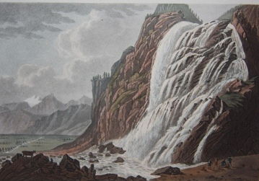
Schoberl, Frederic. Illustrated by J. and J. Lory. Picturesque Tour from Geneva to Milan, By Way of the Simplon: Illustrated with Thirty Six Coloured Views of the Most Striking Scenes and of the Principal Works Belonging to the New Road Constructed Over that Mountain, Engraved from Designs by J. and J. Lory, of Neufchatel; And Accompanied with Particulars Historical and Descriptive by Federic Schoberl. London: R. Ackermann, 1820. First Edition. Imperial 8vo. 11 by 8 inches, 29 by 20 cm. [8], 136, [2], 8 pp. Plus 36 hand-colored aquatint plates, and tinted frontis map. Includes useful publisher's eight page catalog. One of the most beautiful of plate books, capturing some dramatic and treacherous scenery. Views include Sion, Lake Geneva, Brieg, Bridge at Ganther, Algaby, Ponte Alto, waterfall at Pissevache, bridge at St. Maurice, Lake Maggiore, Arona, Sesto, Milan, Lake Como, etc. Tooley 446, which notes that the work was issued later with title still dated 1820, but that is manifestly not the case here since plates are dated 1819 and 1820 and the publisher's quarter leather binding is consistent with the first issue as thus. (Some plates were issued earlier in Ackermann's Repository.) The publication itself should be seen as a product of the building appreciation of Alpine and Swiss scenery, once scorned, that began in the 1700s, and in particular British fascination with it. Custom clamshell case. Some offsetting from plates, including from frontis to title. Soiling of frontis in margins especially. Clamshell box has a few loose seams along joints and other minor wear. Plates have watermarks from 1819 and 1820. Very Good. Quarter Morocco over Cloth Boards, with Custom Cloth Clamshell Case. (#002054) $5,400 £3,575

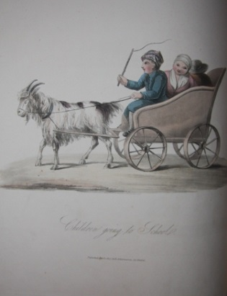
Miss Semple. The Costumes of the Netherlands, Displayed in Thirty Coloured Engravings after Drawings from Nature With Descriptions in English and French. London: Ackermann's Repository of the Arts, 1817 or 1819. Folio. 30 hand-colored plates plus title page vignette. Title page gives 1817 as publication date, and plates are watermarked 1817, but front pastedown label gives date of 1819. 14.5 by 10.5 inches. 37 by 27 cm. With original publisher's boards and label. Rebacked with matching cloth. Boards are soiled and scuffed, with red surface paper rubbed off along edges and corners. Still attractive binding. Scattered light foxing and soiling within, but overall impression is of clean and fresh. One plate with tiny pinprick hole. Very Good. Paper pastedown onto boards. (#002111) $2,750 £1,825

Shakespeare, William; Illustrated by Paul Woodroffe. Series edited by Ernest Rhys. Songs From the Plays of Shakespeare From The Illustrated English Poems Series. London: Aldine House, 1898. First Limited Edition . Number 4 of a limited edition of ten printed on Vellum for the Guild of Women-Binders and colored by hand and signed by Miss Gloria Cardew. 85 pp plus twelve color plates, along with many hand-colored vignettes. Gorgeous full brown morocco decoratively stamped with gold roses and border on covers, spine, and turn-ins, by Bradstreet's. Joints, tips, and edges rubbed with surface loss, few light soil marks and some areas of uneven discoloration; watered silk endpapers, dampstains to top margins of FEP (which blends well with moire pattern in any event), colophon, half-title, and frontispiece. Very Good. Full Morocco. (#001726) $2,750 £1,825

Silva, Arturo. Illustrated by Richard Flavin. Philosophy of the Shirt. Tokyo: Jionji Press, 1986. First Limited Edition. A charming homage to the shirt and shirtanalia, for the shirtaphile who refuses to accept short-shirting of the matter. Laced with witty, quotable faux haikus and other verse: "Shirts are a matter, not of design, but of engineering." Or: "Shirts are prose narratives in the third person singular." Or wrap your shirt sleeves around this one: "What do I care for pants? I could wear the same pair for a month; but I have to change shirts at least three times a day." Lest the spare verse seams [sic] to shirt plain meaning, there is a pop-up shirt book and a sublime relief of a shirt collar on the title to delight the shirtaholic. Black handmade paper covered (shirted) boards, with matching black endpapers. Tanaka handmade paper printed on one side only of double leaves in the traditional Japanese manner. Bound with the fold at the fore-edge. Unpaginated, 18 pp. No. 22 of 222, signed by both author and artist, who wore their workshirts during the book creation. Fine. Cloth. (#002369) $340 £225

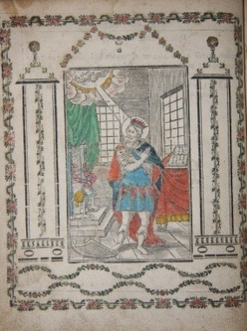
[Slavonic] Church Slavonic Psalter and Liturgical Book [The Psalter of the Blessed Prophet and King David, With Various Parts on the Feast of the Lord, Mother of God, and Saints] Psaltyr' Blazhennago Proraoka i tsaria Davida: S Pisnymy i Prypivy i Stikhi Isbrannymi na Prazdniki Gospodski i Bohorodychny i Sviatykh Bozhiih: S Kanonom Molibnym i Paskhaliieiu. Vienna: Tipom Isadadiesia v Tsarstvuiushchim , 1776. Quarto, 20 by 20.5 cm. Distinctive for the hand-coloring of a four woodcut illustrations and 33 of the 42 head and tail pieces within this unusual Slavonic liturgical work. Some other letters are rubricated in red. Also distinctive is the large and clear lettering throughout. The binding is of a course burlap like fabric, and is presumed near contemporary. The book has suffered some smoke damage, most apparent on the sides of the title and the binding material, with traces on the fore-edges. Otherwise the contents are soiled, but to an acceptable level. New endpapers. Good. Cloth. (#002524) $1,250 £830

Szyk, Arthur. Arrangees par Curnonsky & J. W. Bienstock. Le Juif Qui Rit Deuxieme Serie. Paris: Albin Michel Editeur, 1927. 8vo, 222 pp. Original wraps bound in full morocco binding. Humorous anecdotes and one liners illustrated with Szyk line drawings, from the time when Szyk was residing in Paris. A beautiful binding, with just one minor abrasion on front. Pages are age toned, and edges of leaves are somewhat roughly cut. Fine. Full Morocco. (#001581) $500 £332

Tasso, Torquarto; Annotations of Scipio Gentili and Giulio Guastavini. La Gierusalemme Liberata di Torquarto Tasso. Genoa: Girolamo Bartoli, 1590. 1st Edition thus. Book. 8vo - over 7¾ - 9¾" tall. First illustrated version of "Gerusalemme Liberata". 255, 69, 40, [8] pp. With 20 plates of illustrations and illustrated title page, along with decorative tail and header elements framing each canto. Quarto, 9.5 by 7 inches or 24 by 17 cm. Brunet V 665. Gamba 948. Govi 137. (Govi, I Classici Che Hanno Fatto L'Italia, giorgio Regnani Editore, Modena 2010.) Agostino Caracci, brother of the more famous artist Annibalee Caracci -- both worked on celebrated frescos of the Palazzo Farnese in Rome -- contributed to the ornamenting of the plates to Canto 6, 7, 8, 10, 12, 16, 17, 19, 20. Bound in nineteenth century vellum, with also Victorian Era marbled endpapers. Soilage scattered throughout, yet text remains attractive. Plates are also quite vivid and bright, with some soilage in their margins. Prior owner stamped an oval seal on the base margin of the plate, not touching the plate, and this impression while generally faded, also has shadow on facing page. Vellum has light soilage but remains healthy. Boards are flat -- no warping of vellum. Minor chip to title label and to place/year label, in neither case affecting gilt lettering. Very Good. Hardcover. (#001147) $6,000 £3,975

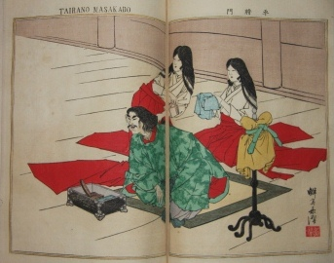
Teicki, Miki. Translated by Takahashi Kyushundo. Short Biographies of Eminent Japanese in Ancient and Modern Times Each With a Characteristic Illustration The Japanese and Chinese. Tokyo. N.d., circa 1880. 4to. A leporello or concertina bound in a string-tied wrapper. (Thus the concertina doesn't open up laterally.) Each of the ten double-paged color woodblock illustrations is accompanied by a biography of the figure portrayed. The biographies are rendered in both English and Japanese, with two or three pages devoted to each figure in each language. The wraps are soiled somewhat. Within occasional light soiling and some light wear from use. Very Good. Wraps. (#002533) $675 £447

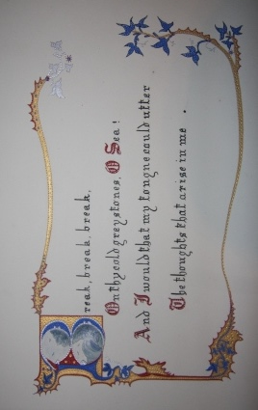
Tennyson, Lord Alfred. Leonard Charles Price, probable artist and illuminator, Break, Break, Break, Illuminated. . An unusual subject for illuminated manuscript treatment, and pulled off with panache. Ten leaves of fine watercolor and ink illustrations, calligraphy and sublime ornament in the tradition of Victorian illuminated manuscripts, all with ship or boating interest. Oblong, 8.5 by 14 inches, 22 by 36 cm. Some artwork mounted, most done directly on card, all by the same hand, and presumably of Price, whose bookplate is mounted onto the FEP. Shelfwear to leather, heavy along edges. Rebacked. Leaves on heavy card, and these are clean and bright. Very Good. Full Morocco. (#002581) $2,250 £1,490

Tesauro, D. Emanuel; Annotations of D. Valeriano Castiglione. Del Regno D'italia Sotto I Barbari. Venetia (Venice): Giacomo Hertz, 1680. Book. 12mo - over 6¾. [24], 732 pp + [72] unpaginated index. 58 engraved plates, 3 folding maps. Libreria Vinciana (Autori Italiani del 1600) 499. History of Italian monarchs during darkest of the Dark Ages, or the period following the fall of the Roman Empire til around 1000 A.D., a period obscure to even most ardent history buffs and scholars. Consulted by Manzoni in his research of Longobardi, or the Lombards. Each of the plates of ancient kings decorated with emblems and baroque ornamentation. Contemporary vellum attractive. Binding tight. Light soilage at most to leaves -- mostly just age toning. Discreet very old writing below half title plate and backside of same leaf. A small wormhole in upper left affecting pages in the 200s but only a few pages where actual letters are lost, and even these pages reading loss is insignificant. Overall a very good copy. Very Good. Hardcover. (#000806) $675 £447
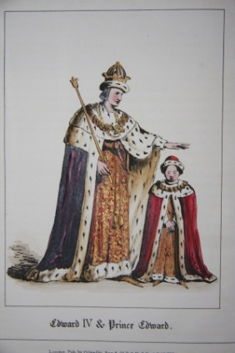
Tomkins, C. F. After the drawings and with the descriptions of J. R. Planche. Twelve Designs for the Costume of Shakespeare's Richard the Third. London: Colnaghi and Son, 1830. First Edition. In addition to the twelve costume plates, an illuminated half-title page. Folio, measuring 12.5 by 9.25 inches. [x], 20 pp. Modern blue calf over blue moire boards. Modern plain endpapers. Light scattered foxing on the text leaves. One plate trimmed on the bottom. Plates are bright and fresh. Very Good. Quarter Calf. (#002302) $975 £646
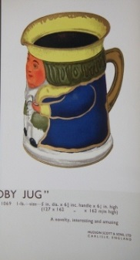
[Trade Catalogue] 1937 Decorated Tin Boxes. Hudson Scott & Sons Limited. Carlisle, England. A beautiful, and colorful, catalog of tin boxes. 47 pp. The tins are decorated in a multitude of styles, with Asian (Japanese, Chinese, Indian) influences particularly strong, but also Regency, deco-ish and other styles popular at the time evident in some tins. The leaves are printed only on the recto sides. Some of the tin images are mounted, others are printed directly onto the leaf. The mounted tins appear to be of very thin tin and thus particularly authentic representations of the actual tins. Below the illustrations are dimensional, price and other descriptive text. A scarce trade catalog, with none located on OCLC. Light soiling to the wraps. The mounted tins have a tendency now to curl at the base. Bound with ribbon and a short string attached to the top. Very Good. Wraps. (#002479) $650 £430

Tuer, Andrew W, Old London Street Cries and the Cries of To-Day with Heaps of Quaint Cuts INcluding hand-coloured Frontispiece. London: Field & Tuer, 1885. First Edition. An uncommon fully hand-colored copy of the classic on London street life of yesteryear. 12mo. (13 by 10 cm, 5 by 4 inches.) 137, [7] pp. Pebbled marbled paper pastedown with soiling and rubbing on spine. Paper finely torn by joints, now repaired. A few fox marks on title label pastedown. Generally clean and tight within. Very Good. Paper pastedown on boards, with ribbon tie. (#002295) $275 £182

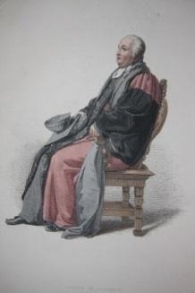
Uwins, Thomas. The Costume of the University of Oxford, Illustrated by a Series of Engravings from Original Drawings by Thomas Uwins. To which is prefixed a brief account of the members and officers of that university. London: R. Ackermann, 1815. First Edition. Folio-sized, measuring 13.5 by 10 inches, 34 by 25 cm. With 17 hand-colored plates of academic dress, which was then more nuanced by position and status. Included are doctor in divinity, doctor in in physic, doctor in law, doctor in music, master of arts, bachelor of arts, a nobleman, a gentleman commoner, a commoner, a student in civil law, a scholar, a proctor, a servitor, a collector, a vice chancellor, beadles and a verger. While the palette of costume is more muted and restrained than typifies other Ackermann costume collections of the time, the plates are both elegant and evocative of Regency style and ideals. The text and plates are clean. Modern brown calf over marbled boards. A hard to come by title in lovely condition. Fine. Quarter Morocco. (#002318) $1,500 £995

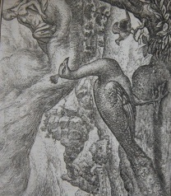
Van den Vondel, Joost. Emblems by Marcus Gheeraerts, G. de Jode, etc. Vorsteliicke Warande der Dieren. De Helden Godes des Ouwden Verbonds. De Heerlyckheyd van Salomon. Hierusalem Verwoest. De Vernieuwde Gulden Winckel der Kunstlievende Nederlands. (Five works bound in one). Amsterdam: D. Pietersz, 1617-1622. First Edition (except the last work which is a second). Vorsteliicke Warande with 125 half-page copper engraved emblem plates; De Helden Godes, with vignette title and 38 copper engraved biblical emblems; De Wiernieuwde Gulden Winckel with vignette title and 73 half-page copper engraved biblical emblems. The two other works with vignett title and letterpieces. Emblems of Vorteliicke Warande especially charming, with most portraying animals with anthropomorphic brio. Landwehr 886, 877. This set has bookplate from Landwehr and was his personal copy. Calf spine dry and rough. Joints dry, rubbed and cracked. Interior is tight and attractive. Very Good. Full Calf. (#001946) $8,500 £5,630

Vegetius, Renatus Flavius. Vier Bucher Der Ritterschafft. Zu Dem Aller Durchleuchtigesten Grossmachtigesten Fursten Und Herzen Herrn Maximilian Romischen Kaiser Loblicher Gedactnus . . . Augsburg: Steiner, 1529. First Edition Thus. 4to - over 9¾. Book. 121 full-page woodcut illustrations, plus two half-page woodcuts and title page illustration, for a total of 124. 100 unnumbered leaves (leaves Miii & Miiii apparently provided from another edition) + 3 leaves from an unrelated work bound in at the end. Lipperheide 2043. Not in Adams. Extra leaves appear to be from 1527 Steiner edition. Cf Adams V339. Later vellum by Bouillet, gilt spine. Yapp edges. All edges gilt. Title within woodcut border with half-page pictorial woodcut vignette. Covers bowed. Minor foxing, soiling and browning. A few minor marginal tears. Overall, tight and generally fresh and sound internally. Fine. Vellum. (#000684) $13,500 £8,940

Versailles Illustrated, or Divers Views of the Several Parts of the Royal Palace of Versailles; as likewise of all the Fountains, Groves, Parterras, ye Labyrinth & other ye most Beautiful Parts of the Gardens, Wherein are represented whatever is remarkable whether Statues, Group of Figures, Water Falls, Pleasure Houses, &c. Drawn on the Spot by the Order & with the Approbation of the French King. London: John Bowles & Son, 1730. Oblong folio (16 by 12 inches, or 40 by 30 cm), with 30 copper engraved plates including title page. Plates within are usually encountered framed on walls, but perhaps the most interesting plates are the final six plates which are each divided into six parts and these render the fables of Aesop as they are expressed in the fountains. The old marbled wrappers have been bound in lush green full morocco. Some foxing in margin of title page and last plate, which also have minor edge chipping. Otherwise plates are quite clean. Very Good Plus. Full Morocco. (#001558) $4,750 £3,145

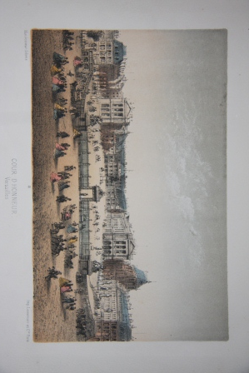
Versailles et Trianon. Paris: Imprimerie Lemercier et Cie. Hautecoeur freres, Martinet. Oblong, 26 by 17 cm, 10 by 6.75 inches. With sixteen hand-colored views of the main palace, its grounds and fountains, and the Trianons. With no title other than that which is on the binding, this is a collection of views that were either assembled by the tourist and then bound, as was done then, or more likely, bound with some randomness by the souvenir shop. This can be inferred by the views bearing numbers but not having any particular order in this album. In any event, the pictures are delightful. Other than a very occasional fox mark in the margins, the plates are clean. The red cloth is faded, with soiling along the hinge and scattered elsewhere. Minor repairs to the hinge. Very Good. Cloth. (#002321) $500 £330

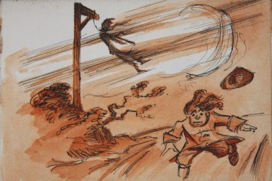
Vulliamy, C. E. Scenes and Characters of the English XVIIIth Century, all, with the exception of one or two Portraits, Original. A complete manuscript book containing 34 pen and sepia wash pictures, each captioned on the facing leaf by the hand of Colwyn Edward Vulliamy (1886 - 1971). Vulliamy was a Welsh biographer and historian. Educated privately, he studied art under Stanhope Forbes. In World War One he served in France, Macedonia and Turkey. Post-war, in addition to biography, he produced several mysteries and dabbled in humor writing. This album beautifully combines his affinity for history and humor, and one could only wish he had devoted more of his later energies to such caricature. The subject matter is of some historic remove from Vulliamy, but surely the album reflects the surge of interest in the eighteenth century that occurred at the turn of the twentieth century. Here one will find both a wistful and jaundiced look back -- Vulliamy doesn't look away from the seedy and ugly aspects of Georgian England. His style and wash media are true to the period, and but for the paper stock and the binding, one could be easily deceived into thinking the artwork was in fact contemporary with the period depicted. The front endpaper is signed and dated by the author, and he again initials and dates the closing illustrated leaf. Quarter leather over pebbled cloth binding, measuring 9.5 by 13.5 cm, or 5.25 by 3.75 inches. Some spotting on the black cloth. Otherwise, quite fresh and clean. Very Good Plus. Quarter Leather. (#001966)
$850 £565

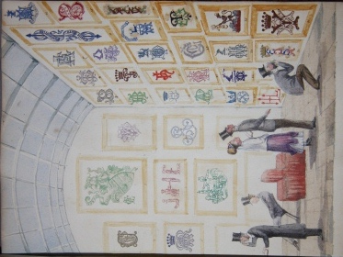
Wardlaw, Mary. Monogram Album with Monograms Incorporated into Watercolors and Ink Drawings. Crebilly, Ireland, 1869. A marvelous monogram album in which the monograms are creatively incorporated into charming watercolor and ink illustrations. 8vo. Unpaginated, with 77 leaves with content, including title, with monograms and watercolors and/or ink drawings on the rectos, and lists of names, corresponding with the monograms, on most of the facing versos. The title page features what is almost surely a fine drawing of Crebilly Manor House. Following this, highlights include illustrations of a pergola and beehive, an art gallery, a pyramid, porcelain, acrobats, a boy blowing bubbles, a man painting on a large canvas, like a billboard, with onlookers, a hot air balloon with Blarney Castle written on it, and the finale scroll with putti. But there are no illustrations that do not exhibit creativity and clever composition. Even the simpler, more geometric designs transcend what one generally finds in more standard monogram albums. Further, seldom is a monogram album such as this from a known collector, compiler and artist. Mary Wardlaw, who was responsible for the splendid, imaginative settings of the monograms, was the wife of General Robert Wardlaw, and their seat was Crebilly, a large estate in Antrim County in Northern Ireland (still a part of the U.K.). There is light marginal soiling on the title page, which along with a few leaves after, juts out slightly from the rest of the text block. The full red morocco binding is rubbed along the joints. Very Good Plus. Full Morocco. (#002525) $9,500 £6,295

Mary Wardlaw. Monogram Album. Crebilly, Ireland. N.d., circa 1860s. 8vo. Unpaginated, with 24 leaves containing monograms neatly arranged in geometric designs executed by the compiler, or done directly into the album, and occasionally a more elaborate illustration, including that of a playing card and of crossing flags. Mary Wardlaw was the wife of General Robert Wardlaw, and their seat was Crebilly, a large estate in Antrim County in Northern Ireland (still a part of the U.K.). The binding has shelfwear and rubbed edges. Rebacked, with the original spine preserved and mounted. Light soiling scattered within. Very Good Minus. Full Blindstamped Calf.
Full Morocco (#002541) $800 £530

Warren, Henry. Notes upon Notes with Cuts from Copper and Music. London: R. Ackermann, 1832. First Edition. 12mo. 47 pp with seven hand-colored plates. A light-hearted, discursive discourse on music, touching on a variety of musical topics and linking them to people in various ways -- as metaphor, as the basis for anecdote, etc. Only three copies turning up on OCLC, and seldom turning up in the marketplace in this condition. Miniscule chip in upper corner of title page. Occasional light soiling. Moderate toning of leaves. Modern green morocco and newer endpapers and blank prelims immaculate and attractive. Near Fine. Full Morocco. (#002131) $675 £448

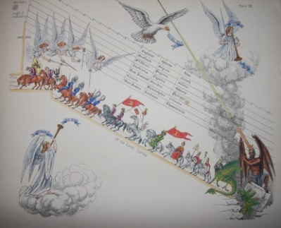
A Watcher [probably a Mrs. Worsley]. Modern Hieyoglypics [sic] of The Apocalypse and Great Pyramid. London: Jones & Cuthbertson, 1878. First Edition. A quirky, present-time take on the Book of Revelations and its apocalyptic prophecies, with imagery that is minutely conceived, detailed, and paradoxically, rather cheery notwithstanding its grim intent. The work might fairly be categorized as an emblem book. Given the highly symbolic nature of Revelations, even to the literalist, this is scarcely a stretch. In terms of actual content, the book purports to predict events that will befall mankind in the near future -- four years into the future from 1878 and the Congress of Berlin as a starting date. To what degree the author actually believed in the predictions is open to question, although there can be no doubt that she did believe in fundamental truths informing the predictions, and the intricate marshalling of her points suggests ardent conviction. For us, however silly or profound we might consider the narrative, the visual entertainment of the vivid illustrations is immediate and undying. Oblong folio-sized, measuring 16 by 13 inches, 41 by 33 cm. Each of the ten hand-colored plates is accompanied by a page of text that provides an expository explanation of the plate and a section directly quoting from Revelations. Quite scarce, with only four institutional holdings turning up on OCLC. Rebacked with a darker blue cloth that blends well with the boards. Scuffs on the boards and moderate to heavy edgewear. Some light finger soiling within; otherwise, generally clean. Very Good. Decorated Cloth. (#002123) $950 £630

[Watercolors] Collection of a Dozen Postcards Featuring Original Watercolors and Ink and Pencil Drawings. An extraordinary group of original artwork from the early twentieth century, with short text written on a few of the cards. The artwork was all done by a B. Vinya and sent to a D. Enrique Montagut in Alicante, which is on the Mediterranean Coast of Spain. Subjects of the watercolors include an elderly guitarist, a young family looking off to the sea's horizon where there is the fishing craft of the father and husband, a picturesque old mill, two country landscapes, several sailing vessels, a European woman dressed like a Geisha, lovers on coastal rocks and a woman with a fan with a Venetian backdrop. The three ink or pencil drawings are stylistically quite varied, with elements of Daumier in one, more contemporary caricature in another, and yet the third a good-hearted depiction of carousing monks. Each of the pictures is of a quality worthy of framing, and cumulatively they make for an uncommon and pleasing oeuvre. Very Good. (#002440) $670 £445

Watt, Isaac. The Psalms of David. Imitated in the Language of the New Testament. And Applied to the Christian State and Worship. [Bound with] Hymns and Spirituall Songs in Three Books. London: J. W. Parsham, 1778. 2 volumes in one. 12mo (4.75 by 3", 12 by 7 cm),. [4], 240, [20], [4], 216, [26] pp. Above all else, this is a beautifully painted vellum binding in the style of the Edwards of Halifax, a family of bookbinders in the late 18th century who developed a process of producing painting on vellum or parchment. The painting would actually lie under the surface, giving it a greater permanence as well as a subtle glassy aura. On the front of this particular binding is a lady, in late Georgian attire, playing an organ with a cherub at her side and a lute at her feet. The rear board has a tinted illustration of a castle in a park-like setting. The spine is divided into five compartments, four of which have a lyre ornament. Gilt ornamental borders and other detail work add further refinement to the binding. This comes with a brown levant gilt folding case, shaped like book, octavo in size, and with plush interior with resting compartment for book itself, by Sangorski & Sutcliffe. The joints of the book are partly cracked. The first title page has some light soilage. There is a small tear, partially repaired, on pp 1/2 of the second work. The vellum has light soilage and wear. The box has rubbed front joint and some minor scuffs and rubbing along edges. Notwithstanding these issues, the book remains a highly attractive work of book art. Near Fine. Hand-Painted Vellum; With Full Morocco Box. (#001367) $5,000 £3,315

Webb, Harriet. Album of Drawings and Poetry. Staffordshire (?). No one date, 1830s to early 1840s. Unpaginated, 100 leaves, of which 32 have pictorial content, many others have poetry, and yet others are blank. Of the pictorial pages, about 20 of the pages can be considered original art, meaning freshly applied watercolor, pencil or ink, with most of these applied to paper then mounted to the album, and done by either Harriet or Henry Webb. The remainder are prints, some of which are hand-colored. Highlights include a watercolor of Lee Halll, Armitage, Stafforshire, which is presumably the home of Ms. Webb; two other pencil renderings of this manor house; a lakeside panorama; a watercolor of men fishing; a watercolor of a lady with a fan; Some of the poetry appears to be original, while some pieces are clearly copied. Consistent with the time period, most of the poetry fits neatly into the romantic style. The full brown morocco binding remains handsome notwithstanding considerable wear, scuffing, and rubbing and starting along the joints. Some leaves have heavy foxing, while others are quite clean. Very Good Minus. Full Morocco. (#002542) $800 £530

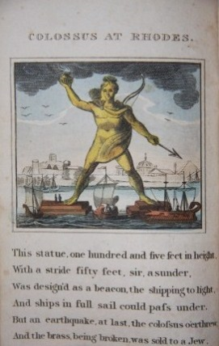
Wonders! Descriptive of Some of the Most Remarkable of Nature and Art. St. Michael's Volcano, Pyramids and Sphinx. Giant's Causeway. Palace and Statue of Memnon. Termites, Ant-Hills, and Pyramids. Ice Mountains. Great Wall of China. St. Winifred's Well. Mausoleum of Hyder Ali. Chapel of the Holy Sepulchre. Stonehenge. Pompey's Pillar, and Cleopatra's Needle. Fingal's Cave. Grotto of Antiparos. Colossus at Rhodes. Pont du Gard. London: J. Harris and Son, Corner of St. Paul's Church-yard, 1821. First edition. Each of the Seven Wonders or natural phenomenon covered is accompanied by six lines of doggeril. There are 16 pages in all, with printing on one side of the leaves, which measure 17 by 11 cm, or 6.5 by 4 inches. Interesting as an early glimpse on faraway places and strange facets of the natural world and also as early juvenalia. Clean, with a few of the leaves cut tightly, with a few letters partly dropped in the text. Very Good. Wraps. (#002023) $650 £430

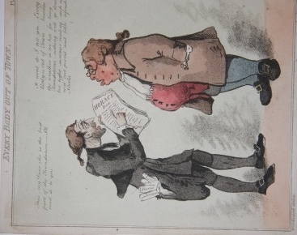
Woodward, George Moutard. Sansom and Barrett, engravers. Everybody in Town. Everybody Out of Town. Two collection of scarce hand-colored caricature/genre plates by Woodward, for a total of twelve plates. The satirical plates play on the ever growing predilection of the fashionable world to divide its time between town and country and the feelings of dislocation from not being able to keep up with the demands of that lifestyle or simply being in the wrong setting for the season. The wit intended by the dialogue may be obscure to modern audiences; the illustrations, however, really need no textual explanation, and they sparkle as much now as two centuries ago. Not in Abbey. New York Public is shown as having both sets, Yale has one; otherwise, all holdings are of individual plates. Lacking title leaves. Soiling scattered on the plates, and corners can have darkened circles, about an inch in diameter, where these plates may have once been pasted into an album. Library Modern folio folder houses plates. Very Good Minus. (#002593) $3,600 £2,380
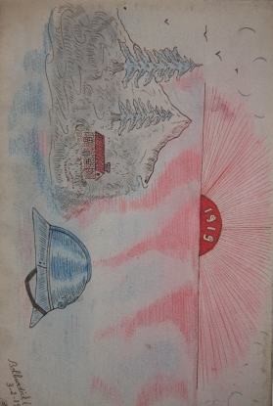
[World War One] Denizot, Toussaint. Souvenir de l'Occupation. Bedburdyck. Album with 21 pages of fine color drawings rendered in February and March, 1919 in the immediate aftermath of World War One during the French Occupation of Westphalia. The drawings were done by a French soldier, Toussaint Denizot, who was a cyclist with the 3rd company of the 97th Regiment in the Alpine Infantry. This was a regiment hailing from Chambery (in the Rhone Alps of Savoia in the Southeast of France) that was actively engaged on the Western Front during the entirety of the war. Most of the illustrations touch in some way on the war, whether in the depiction of death or loss, anti-German scenes, or light hearted moments, and even the drawings that might seem at first blush unrelated tend to have a subtle reference to it. The style of the drawings is emphatically naive, but there is a strength and cohesiveness to the imagery that suggest that this might well have been a deliberate choice by Denizot, as opposed to a consequence of artistic limitations. Because of this cohesion, the somber palette, the sheer beauty of the production, the album exudes an extraordinary power, making it a humble yet valuable documentary relic from the war to end all wars as seen by an ordinary soldier. (#002567) $1,950 £1,295

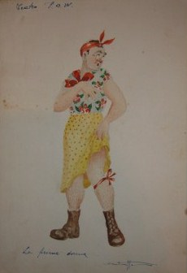
[World War Two] Album of Watercolor Illustrations from a World War Two P.O.W. Depicting P.O.W. Theater. Burgeret, Kenya, 1943. Highly unusual album of original art done by an Italian P.O.W. imprisoned in Africa during World War Two. In a mere twelve leaves the artist depicts the more frivolous, bearable aspect of being a P.O.W., with its drag shows, its food lines, its attempts at normalcy. Rendered with a light touch and great economy, the scenes evoke the musical South Pacific, and the artwork itself has the narrative drive of a Norman Rockwell work, perhaps surprising given that the artist was an Italian. So here we have several depictions of soldiers in drag and other costume. Burguret, where this work was done, was a P.O.W. camp located in Kenya. Although all the works are signed, it is impossible to read the signature. There is a note on the first leaf in which it appears an Italo Puglese is dedicating the album to a Lieutenant Blencome, who "With his generosity he has made my prison days a little more cheerful." The words that follow are illegible and thus undermine a clearcut identification of the parties. Nevertheless, the charm and skill of the drawings are undeniable, and as a contemporary account of life in the camp, whoever was responsible, invaluable. The album binding is heavily soiled. The staples binding the leaves are rusty, and two leaves are loose. Minor toning and soiling to the illustration pages. Oblong album, measuring 10 by 7 inches, 27 by 18 cm. Very Good. Cloth. (#001983) $1,750 £1,160

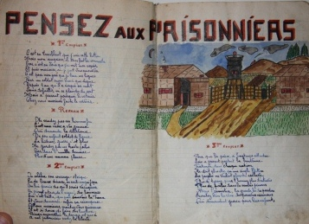
[World War Two] Osteng, Leon. Cahier de Chansons Commence en Captivite Le 1/10/1941. Stalag VII A, Germany, 1941-1945 (?). An extraordinary, charming World War Two Prisoner of War illustrated songbook manuscript! With 60 pages of song lyrics and colorful watercolors of Stalag VII A, idealized women, a bullfighter, birds and flowers, an ocean liner, fanciful sailors, children, and other fantasy images that must have given great comfort to the prisoner. The songs are entitled "Pensez aux Prisonniers", "Le Moulin Qui Jase", "J'ai Reve D'Une Fleur", "Nice la Belle", "Sous le Soleil Marocain", "Le Raccommodeur de Faience", "Sombrero et Mantille", etc. Some of the songs, such as "Le Moulin Qui Jase", were well-known; others may or may not be original to the prisoner, or have original parts. The lyrics are written with a neat hand, usually with several verses. We know the identity of the artist and writer, as well as his location, from an image of a postcard he drew. It appears that Osteng was from Marseilles. Stalag VII-A (Kriegsgefangenen-Mannschafts-Stammlager VII-A), the largest German prisoner-of-war camp during the Second World War, was located just north of Moosburg in Southern Bavaria. The 86 acre camp served as both a full-time and transit camp, the latter being a place where prisoners were processed on their way to other camps. The camp housed prisoners from all the nationalities fighting the Germans. At its liberation on April 29, 1945, the camp held 80,000 prisoners, most of whom were either French or Russian. The cover has wear. A few leaves have a child's scribbles, and these were probably done later, possibly by a child. Very Good. Cloth. (#002490) $2,450 £1,625

Yoshii, T. Kyoto & Its Suburbs Finely Illustrated. Osaka: T. Nakashimi & Co., 1891. Oblong, 3 by 4.75 inches. 56 pp. plus covers, fold-out city map and 17 color woodblock plates. Also, three lovely color vignettes on FFEP which were probably done later. Foxing on the front cover and scattered lightly on the first few leaves and occasionally beyond. The final leaf has minor chipping by the spine. Mostly clean, with the plates bright and lovely, and the delicate fold-out map entirely present. Very Good. Paper. (#002480) $275 £182

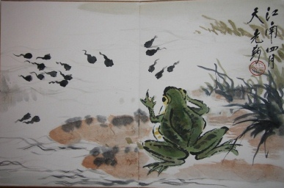
Yun, Tang (1910 - 1993), aka Xiachen. Album of Six Ink and Watercolor Paintings of Depicting Fish, a Frog, a Bird, a Praying Mantis and Fruit, Another Bird and a Crab. . N.d., mid-20th century. Wonderful impressionistic Chinese watercolors after nature. Each of the illustrations measures 14 by 9 inches, and each is signed and inscribed with seals. Tang Yun was a prominent Chinese artist based in Shanghai, where he held a number of prominent positions in leading art schools. Particularly noted for his plant and animal studies, he worked within the established tradition while bringing a modern stamp to it. Wear to the fabric of the covers, with fabric worn through in corners. Otherwise, clean. Near Fine. Leporello, with fabric cover boards. (#002537) $1,200 £795

